**Software Requirements Specification**

**For**

[**Integrated**](http://192.168.10.125:8080/share/page/site/erp-solution-for-wage-earners-w/dashboard) **Digital Delivery Service Platform For**

**Ministry of Agriculture**

**Component 8: Irrigation, Water & Scheme Management System**

|  |  |
| --- | --- |
| **Prepared By** | **Syntech Solution Limited** |
| Document Pages | 190 |
| Version | 1.0 |
| Document Link | https://drive.google.com/drive/u/1/folders/1PVTXQgchaSY_NE7CaBENfbBIMotBx9sD |

**REVISION HISTORY**

|  |  |  |  |
| --- | --- | --- | --- |
| **Ver. #** | **Date of Release** | **Prepared By** | **Reviewed By** |
| 1.0 | 12.11.2020 | Md Amirul Islam Nadim | Rashed Ahmed |
| Limon Biswas |

Table of Contents

**1.** **Configuration** 7

1.1. Project Entry 7

1.2. Add Contractor 9

1.3. Scheme Type 11

1.4. Scheme Form affidavit 12

1.5. Store Item Category 14

1.6. Store Item Sub Category 14

1.7. Add Measurement Unit 15

1.8. Add Store Item 16

1.9. Pump Type 17

1.10. Pump Installation Progress Type 18

1.11. Laboratory Info 19

1.12. Payment Type 21

1.13. Report Heading 23

**2.** **Pump Installation Management System (Module)** 25

**2.1.** **Dashboard** 26

**2.2.** **Application List (Feature)** 27

**2.3.** **Scheme Management (Feature)** 32

2.3.1. Selected for license application (Sub Feature) 32

2.3.2. Current Status (Sub Feature) 32

**2.4.** **Contract Agreement (Feature)** 38

**2.5.** **Requisition (Feature)** 41

2.5.1. Irrigation Equipment Requisition (Sub Feature) 41

2.5.2. Supply Equipment (Sub Feature) 42

**2.6.** **Pump Installation (Feature)** 47

**2.7.** **Pump Operator Selection (Feature)** 50

2.7.1. New Application Lists (Sub Feature) 50

2.7.2. Renew Application Lists (Sub Feature) 51

**2.8.** **Reports (Feature)** 56

2.8.1. Scheme Report 56

2.8.2. Payment Report 57

2.8.3. Pump Operator Report 58

**3.** **Task Management System (Module)** 64

**3.1.** **Dashboard** 65

**3.2.** **Assign Task (Feature)** 66

**3.3.** **Task Calendar (Feature)** 69

**3.4.** **Task Tracker (Feature)** 72

**3.5.** **Reports (Feature)** 75

3.5.1. Task Status Report 75

**4.** **Pump Information Management System** 78

**4.1.** **Dashboard** 79

**4.2.** **Pump Information (Feature)** 80

**4.3.** **Pump Operator (Feature)** 83

**4.4.** **Pump Scheduler (Feature)** 86

**4.5.** **Reports (Feature)** 88

5.5.1. Pump Report 88

5.5.2. Pump Operator Report 89

**5.** **Farmer’s Card and Payment Management (Module)** 92

**5.1.** **Dashboard** 93

**5.2.** **Application List (Feature)** 94

5.2.1. New application Lists (Sub Feature) 94

5.2.2. Reissue Application Lists (Sub Feature) 95

**5.3.** **Generate Card (Feature)** 100

**5.4.** **Reports (Feature)** 101

5.4.1. Application Report 101

5.4.2. Payment Collection Report 102

**6.** **Pump Maintenance & Complain Management (Module)** 105

**6.1.** **Dashboard** 106

**6.2.** **Complain List (Feature)** 107

**6.3.** **Required Maintenance (Feature)** 110

**6.4.** **Maintenance Task (Feature)** 115

**6.5.** **Equipment Supply (Feature)** 121

**6.6.** **Directory (Feature)** 124

6.6.1. Hardware Dealer (Sub Feature) 124

6.6.2. Shops (Sub Feature) 129

6.6.3. Mechanics (Sub Feature) 133

**6.7.** **Reports (Feature)** 136

6.7.1. Complain Report (Searching Parameter) 136

6.7.2. Maintenance Report (Searching Parameter) 137

6.7.3. Rating & Feedback Report (Searching Parameter) 138

**7.** **Water Testing & Survey (Module)** 144

**7.1.** **Dashboard** 145

**7.2.** **Testing Request (Feature)** 146

7.2.1. Irrigation water (Sub Feature) 146

7.2.2. Drinking Water (Sub Feature) 150

7.2.1. Industrial Water (Sub Feature) 154

**7.3.** **Testing Report Collection (Feature)** 155

**7.4.** **Publish water Testing Report (Feature)** 158

**7.5.** **Reports (Feature)** 160

7.5.1. Water Testing Report 160

7.5.2. Testing Payment Report 161

**8.** **Farmer & Operator Panel** 164

**8.1.** **Dashboard** 164

**8.2.** **Scheme Application (Feature)** 165

**8.3.** **Pump Operator Application (Feature)** 171

**8.4.** **Smart Card Application (Feature)** 175

**8.5.** **Water Testing Request (Feature)** 180

**8.6.** **My Task (Feature)** 184

**8.7.** **Payment (Feature)** 187

8.7.1. Scheme Payment 187

8.7.2. Card Payment 187

8.7.3. Pump Operator Fee 187

8.7.4. Water Testing Fee 188

**8.8.** **Complain** 192

New Complain (Button) 192

**8.9.** **Rating & Feedback** 196

Rating & Feedback (Button) 196



# **Configuration**

|  |  |  |  |
| --- | --- | --- | --- |
| Project Entry | | | |
| Field Name | Data Type | Data Length | Mandatory (Yes/No) |
| Select Organization | N/A | N/A | Yes |
| Add New Project (En) | Varchar | N/A | Yes |
| Add New Project (Bn) | Varchar | N/A | Yes |
| Status | N/A | N/A | Yes |
| (Table Format)   |  |  |  |  |  | | --- | --- | --- | --- | --- | | SL No | Project Name | Organization Name | Status | Action | |  |  |  |  | Edit / Delete | | | | |

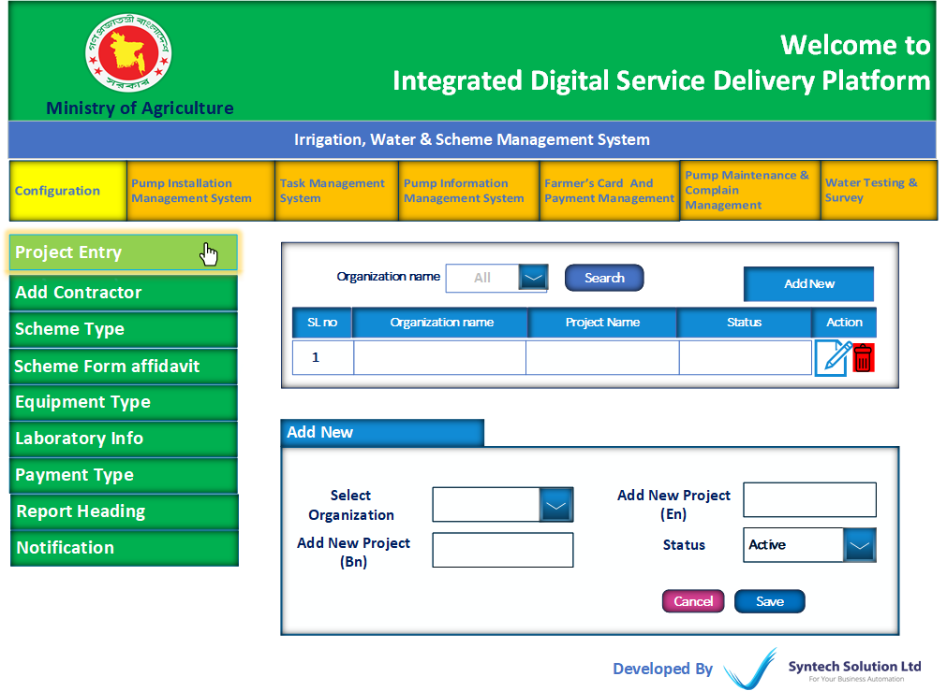

|  |  |  |  |
| --- | --- | --- | --- |
| Add Contractor | | | |
| Field Name | Data Type | Data Length | Mandatory (Yes/No) |
| Select Organization | N/A | N/A | Yes |
| Add New Contractor (En) | Varchar | N/A | Yes |
| Add New Contractor (Bn) | Varchar | N/A | Yes |
| Contractor Address | Varchar | N/A | Yes |
| Mobile Number | Int | N/A | Yes |
| Status | N/A | N/A | Yes |
| (Table Format)   |  |  |  |  |  | | --- | --- | --- | --- | --- | | SL No | Contractor Name | Organization Name | Status | Action | |  |  |  |  | Edit / Delete | | | | |

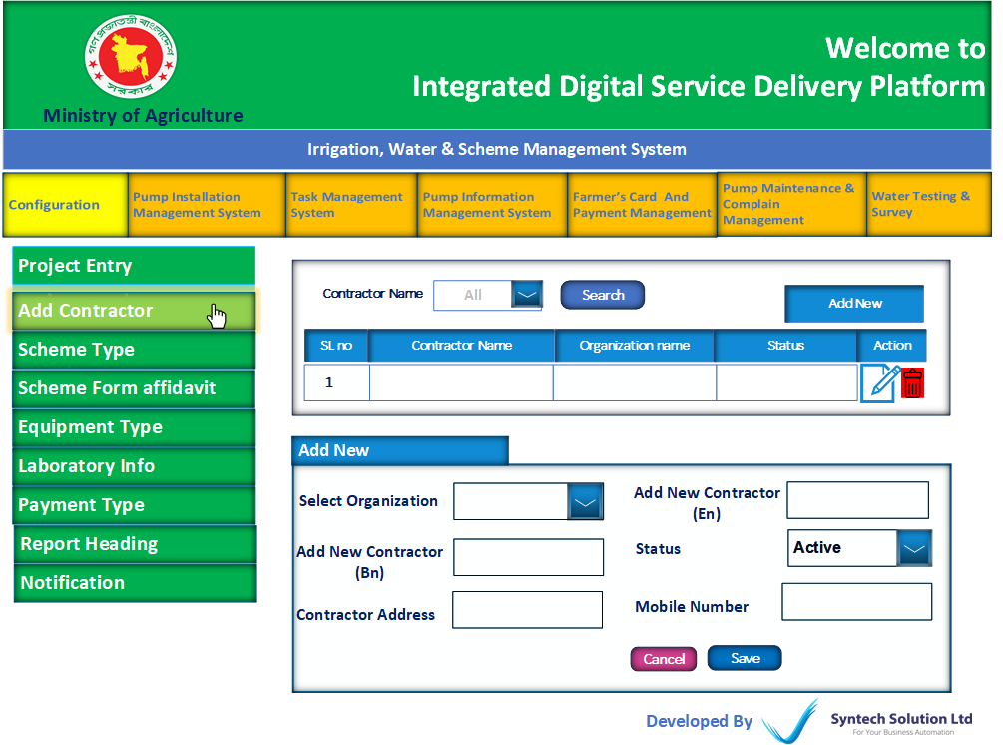

|  |  |  |  |
| --- | --- | --- | --- |
| Scheme Type | | | |
| Field Name | Data Type | Data Length | Mandatory (Yes/No) |
| Select Organization | N/A | N/A | Yes |
| Add Scheme Type (EN) | Varchar | N/A | Yes |
| Add Scheme Type (Bn) | Varchar | N/A | Yes |
| (Table Format)   |  |  |  |  |  | | --- | --- | --- | --- | --- | | SL No | Organization Name | Scheme Type | Status | Action | |  |  |  |  | Edit / Delete | | | | |

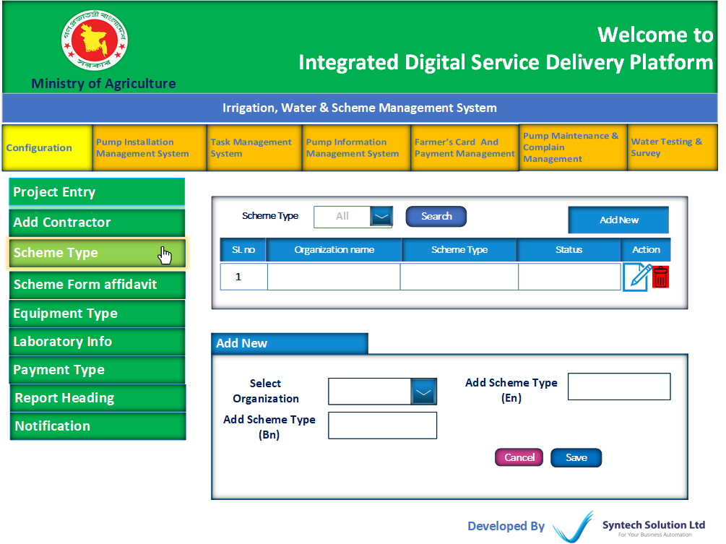

|  |  |  |  |
| --- | --- | --- | --- |
| Scheme Form affidavit | | | |
| Field Name | Data Type | Data Length | Mandatory (Yes/No) |
| Select Organization | N/A | N/A | Yes |
| Select Scheme Type | Varchar | N/A | Yes |
| Add Affidavit (En) | Text Editor | N/A | Yes |
| Add Affidavit (Bn) | Text Editor | N/A | Yes |
| (Table Format)   |  |  |  |  |  |  | | --- | --- | --- | --- | --- | --- | | SL No | Organization Name | Scheme Type | Affidavit | Status | Action | |  |  |  |  |  | Edit / Delete | | | | |

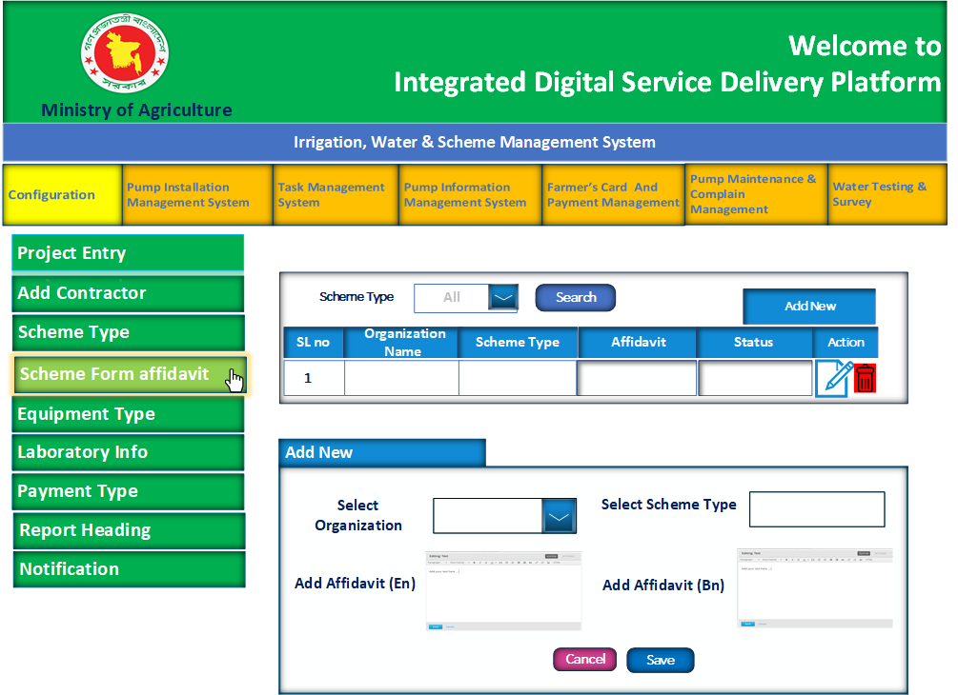

|  |  |  |  |
| --- | --- | --- | --- |
| Store Item Category | | | |
| Field Name | Data Type | Data Length | Mandatory (Yes/No) |
| Select Organization | N/A | N/A | Yes |
| Add Category (En) | Varchar | N/A | Yes |
| Add Category (Bn) | Varchar | N/A | Yes |
| (Table Format)   |  |  |  |  | | --- | --- | --- | --- | | SL No | Organization Name | Equipment Category | Action | |  |  |  | Edit / Delete | | | | |

|  |  |  |  |
| --- | --- | --- | --- |
| Store Item Sub Category | | | |
| Field Name | Data Type | Data Length | Mandatory (Yes/No) |
| Select Organization | N/A | N/A | Yes |
| Select Category | N/A | N/A | Yes |
| Add Sub Category (En) | Varchar | N/A | Yes |
| Add Sub Category (Bn) | Varchar | N/A | Yes |
| (Table Format)   |  |  |  |  |  | | --- | --- | --- | --- | --- | | SL No | Organization Name | Item Category | Sub Category | Action | |  |  |  |  | Edit / Delete | | | | |

|  |  |  |  |
| --- | --- | --- | --- |
| Add Measurement Unit | | | |
| Field Name | Data Type | Data Length | Mandatory (Yes/No) |
| Unit Name | Varchar | N/A | Yes |
| (Table Format)   |  |  |  |  |  | | --- | --- | --- | --- | --- | | SL No | Organization Name | Item Category | Sub Category | Action | |  |  |  |  | Edit / Delete | | | | |

|  |  |  |  |
| --- | --- | --- | --- |
| Add Store Item | | | |
| Field Name | Data Type | Data Length | Mandatory (Yes/No) |
| Select Organization | N/A | N/A | Yes |
| Select Item Category | N/A | N/A | Yes |
| Select Item Sub Category | N/A | N/A | Yes |
| Item Code | Varchar | N/A | Yes |
| Item Name | Varchar | N/A | Yes |
| Measurement Unit | N/A | N/A | Yes |
| Specification | Varchar | N/A | Yes |
| (Table Format)   |  |  |  |  |  |  |  |  | | --- | --- | --- | --- | --- | --- | --- | --- | | SL No | Organization Name | Item Category | Sub Category | Item Code | Item Name | Specification | Action | |  |  |  |  |  |  |  | Edit / Delete | | | | |

|  |  |  |  |
| --- | --- | --- | --- |
| Pump Type | | | |
| Field Name | Data Type | Data Length | Mandatory (Yes/No) |
| Select Organization | N/A | N/A | Yes |
| Pump Type | Varchar | N/A | Yes |
| Horse Power | Varchar | N/A | Yes |
| (Table Format)   |  |  |  |  |  | | --- | --- | --- | --- | --- | | SL No | Organization | Pump Type | Horse Power | Action | |  |  |  |  | Edit / Delete | | | | |

|  |  |  |  |
| --- | --- | --- | --- |
| Pump Installation Progress Type | | | |
| Field Name | Data Type | Data Length | Mandatory (Yes/No) |
| Select Organization | N/A | N/A | Yes |
| Select Pump Type | N/A | N/A | Yes |
| Select Horse Power | N/A | N/A | Yes |
| Add Steps  (Add more) | Varchar | N/A | Yes |
| (Table Format)   |  |  |  |  |  |  | | --- | --- | --- | --- | --- | --- | | SL No | Organization | Pump Type | Horse Power | Steps | Action | |  |  |  |  | Link  Link | Edit / Delete | | | | |

|  |  |  |  |
| --- | --- | --- | --- |
| Laboratory Info | | | |
| Field Name | Data Type | Data Length | Mandatory (Yes/No) |
| Select Organization | N/A | N/A | Yes |
| Add Laboratory (En) | Varchar | N/A | Yes |
| Add Laboratory (Bn) | Varchar | N/A | Yes |
| Laboratory Address (En) | Varchar | N/A | Yes |
| Laboratory Address (Bn) | Varchar | N/A | Yes |
| Status | N/A | N/A | Yes |
| (Table Format)   |  |  |  |  |  | | --- | --- | --- | --- | --- | | SL No | Organization Name | Laboratory Name | Status | Action | |  |  |  |  | Edit / Delete | | | | |

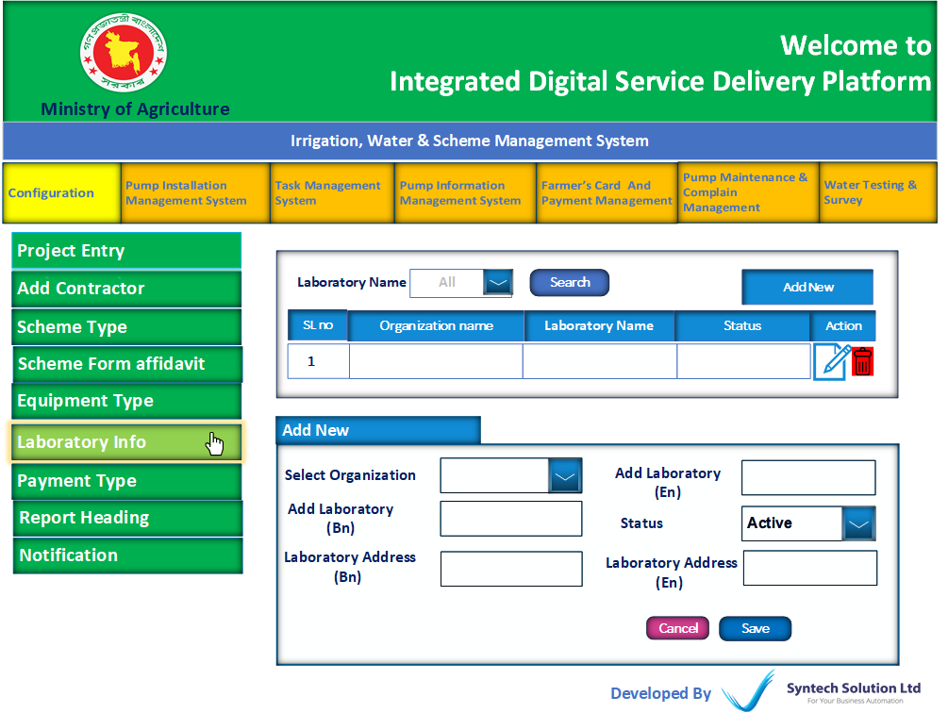

|  |  |  |  |
| --- | --- | --- | --- |
| Payment Type | | | |
| Field Name | Data Type | Data Length | Mandatory (Yes/No) |
| Fiscal Year | N/A | N/A | Yes |
| Select Organization | N/A | N/A | Yes |
| Add Payment Type | Varchar | N/A | Yes |
| Amount | float | N/A | Yes |
| (Table Format)   |  |  |  |  |  |  |  | | --- | --- | --- | --- | --- | --- | --- | | SL No | Fiscal Year | Organization Name | Payment Type | Amount | Status | Action | |  |  |  |  |  |  | Edit / Delete | | | | |

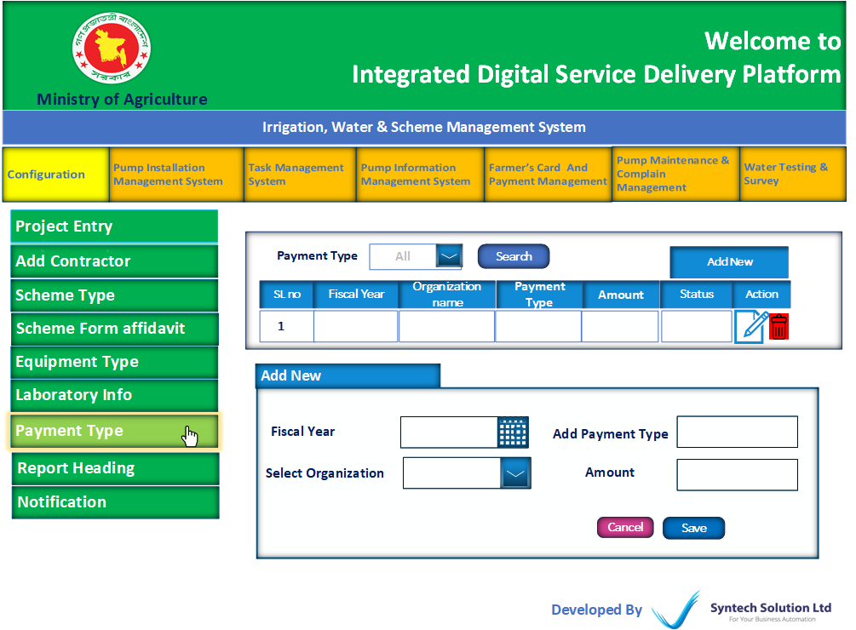

|  |  |  |  |
| --- | --- | --- | --- |
| Report Heading | | | |
| Field Name | Data Type | Data Length | Mandatory (Yes/No) |
| Select Organization | N/A | N/A | Yes |
| Report Heading (En) | Varchar | N/A | Yes |
| Report Heading(Bn) | Varchar | N/A | Yes |
| Left Logo | N/A | N/A | Yes |
| Right Logo | N/A | N/A | Yes |
| Address (En) | Varchar | N/A | Yes |
| Address (Bn) | Varchar | N/A | Yes |
| (Table Format)   |  |  |  |  |  |  |  | | --- | --- | --- | --- | --- | --- | --- | | SL No | Organization Name | Report Heading | Address | Left Logo | Right Logo | Action | |  |  |  |  |  |  | Edit / Delete | | | | |

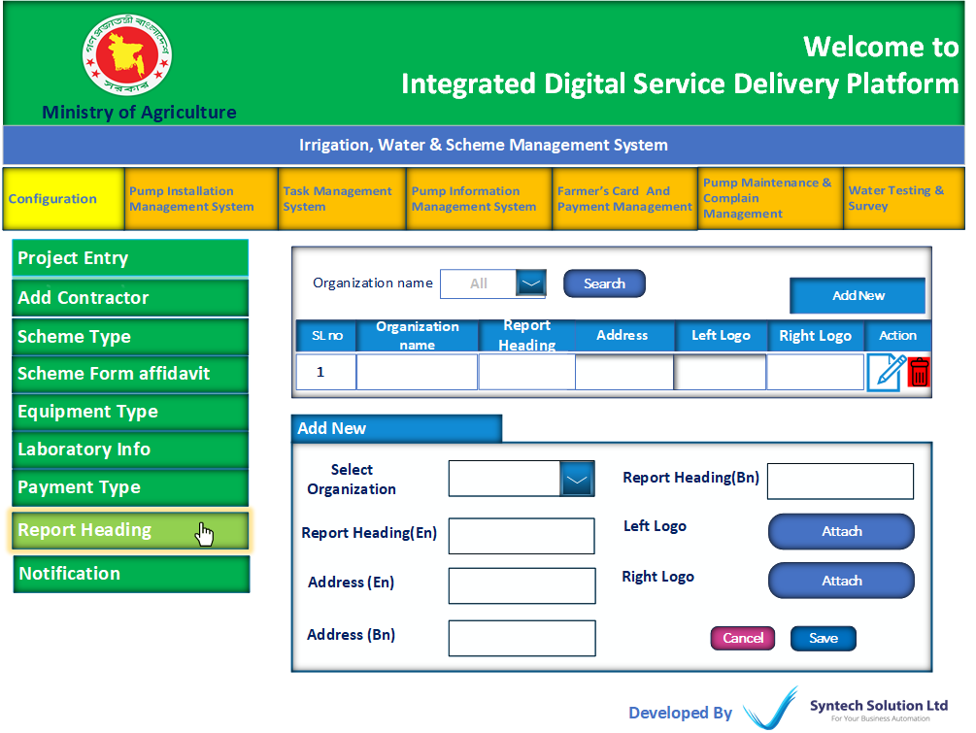

# **Pump Installation Management System (Module)**

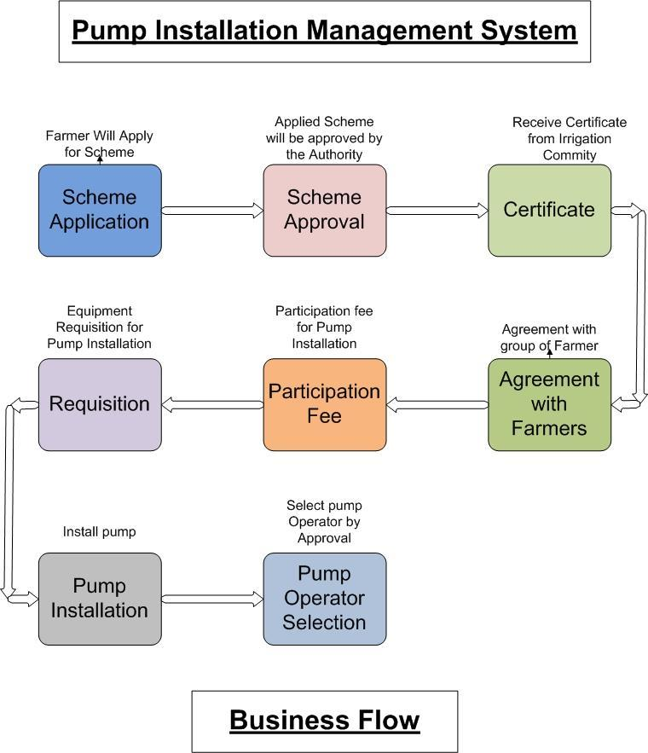

## **Dashboard**

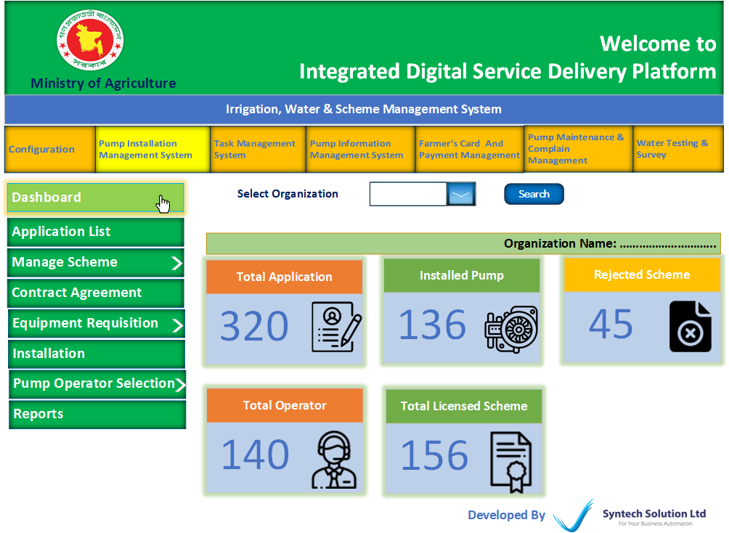

|  |  |  |  |  |  |  |  |  |  |  |  |  |  |  |  |  |  |  |  |  |  |  |  |  |  |  |  |  |  |  |  |  |  |  |  |  |  |  |  |  |  |  |  |  |  |  |  |  |  |  |  |  |  |  |  |  |  |  |  |  |  |  |  |  |  |  |  |  |  |  |  |  |  |  |  |  |  |  |  |  |  |  |  |  |  |  |  |  |  |  |  |  |  |  |
| --- | --- | --- | --- | --- | --- | --- | --- | --- | --- | --- | --- | --- | --- | --- | --- | --- | --- | --- | --- | --- | --- | --- | --- | --- | --- | --- | --- | --- | --- | --- | --- | --- | --- | --- | --- | --- | --- | --- | --- | --- | --- | --- | --- | --- | --- | --- | --- | --- | --- | --- | --- | --- | --- | --- | --- | --- | --- | --- | --- | --- | --- | --- | --- | --- | --- | --- | --- | --- | --- | --- | --- | --- | --- | --- | --- | --- | --- | --- | --- | --- | --- | --- | --- | --- | --- | --- | --- | --- | --- | --- | --- | --- | --- | --- |
| **Application List (Feature)**  * All scheme applications will appear here. * Here User can assign a project, Review Application, Reject the Application, add inspection report, direct approve or present for approval.   (Table Format)   |  |  |  |  |  |  |  |  |  |  |  |  |  | | --- | --- | --- | --- | --- | --- | --- | --- | --- | --- | --- | --- | --- | | SL No | Application ID | Scheme manager Name | Irrigation type (Deep Tubewell/Surface Water) | Application Type | Scheme Location | View Application | Attached Document (link) | Form fee (Taka) | Project | Technical Survey Report | Status | Action | | 01 | 0023 | Arif | Deep Tubewell | New/  Resink | Rangpur | View (Button) | link | 150 | Assign Project  (Button) | Show Report | Pending,/Reject/Reviewed/ Selected | Review (Button),  Survey Report (Button),  Reject (Button),  Select (Button),  Work Flow (Button) |  |  |  |  |  | | --- | --- | --- | --- | | Assign Project (Button) | | | | | Field Name | Data Type | Data Length | Mandatory (Yes/No) | | Assign Project | N/A | N/A | Yes |  |  |  |  |  | | --- | --- | --- | --- | | Review (Button) | | | | | Field Name | Data Type | Data Length | Mandatory (Yes/No) | | Review Note | Varchar | N/A | Yes |  * Review action will appear in the service receiver panel.  |  |  |  |  | | --- | --- | --- | --- | | Survey Report (Button) | | | | | Field Name | Data Type | Data Length | Mandatory (Yes/No) | | Survey Date | Date | N/A | Yes | | Applicant’s Name | N/A | N/A | Yes | | Irrigation Type | N/A | N/A | Yes | | Scheme Address | N/A | N/A | Yes | | Other Note (Add More) | Varchar | N/A | Yes | | Suggestion | Varchar | N/A | Yes |  |  |  |  |  | | --- | --- | --- | --- | | Reject (Button) | | | | | Field Name | Data Type | Data Length | Mandatory (Yes/No) | | Reject Note | Varchar | N/A | Yes |  * Review action will appear in the service receiver panel. |
| **Scheme Management (Feature)**  * Here will show all approved schemes.  |  |  |  |  |  |  |  |  |  |  |  |  |  |  |  |  |  |  |  |  |  | | --- | --- | --- | --- | --- | --- | --- | --- | --- | --- | --- | --- | --- | --- | --- | --- | --- | --- | --- | --- | --- | | Selected for license application (Sub Feature) (Table Format)   |  |  |  |  |  |  |  |  |  |  | | --- | --- | --- | --- | --- | --- | --- | --- | --- | --- | | SL No | Application ID | Scheme Type | Application Type | Scheme manager Name | Irrigation type | Scheme Location | View  Application | Attached Document (link) | Action | | 01 | 0020 | Solar | New/Resink | Arif | Deep Tubewell | Rangpur | View (Button) | link | Have license (Button),  Apply new license (Button) |  * User can apply for irrigation license, manage with component-1 (License, Registration, Clearance, & Certification Management System) / manually. * If application type is new, the action button will be “Apply new license, * If application type is Resink, the action button will be “Have license”. |  |  | | --- | | Current Status (Sub Feature) |  * Here will show All pending license Application * Users can Attach License with license number after getting license manually.   (Table Format)   |  |  |  |  |  |  |  |  |  |  |  | | --- | --- | --- | --- | --- | --- | --- | --- | --- | --- | --- | | SL No | Application ID | Scheme Name | Scheme manager Name | Irrigation type | Application Type | Scheme Location | Applied application | Attached Document | Attach License | Action | |  |  |  |  |  | New/Resink |  | View (Button) | link | Attach License (Button) | Verify License (Button) |   .   |  |  |  |  | | --- | --- | --- | --- | | Attach License (Button) | | | | | Field Name | Data Type | Data Length | Mandatory (Yes/No) | | License No | Varchar | N/A | Yes | | issue Date | Date | N/A | Yes | | Attach Document | N/A | N/A | Yes |  |  |  |  |  | | --- | --- | --- | --- | | Verify License (Button) | | | | | Field Name | Data Type | Data Length | Mandatory (Yes/No) | | License view | N/A | N/A | Yes | | Verify (Button), Close(Button) | | | | |

|  |  |  |  |  |  |  |  |  |  |  |  |  |  |  |  |  |  |  |  |  |  |  |  |  |  |  |  |  |  |  |  |  |  |  |  |  |  |  |  |  |  |  |  |  |  |  |  |  |  |  |
| --- | --- | --- | --- | --- | --- | --- | --- | --- | --- | --- | --- | --- | --- | --- | --- | --- | --- | --- | --- | --- | --- | --- | --- | --- | --- | --- | --- | --- | --- | --- | --- | --- | --- | --- | --- | --- | --- | --- | --- | --- | --- | --- | --- | --- | --- | --- | --- | --- | --- | --- |
| **Contract Agreement (Feature)**  * Here will show all licensed applications which have paid participation fees. * Users will get a predefined agreement format with the text editor. * After signing the agreement the user will attach the signed document for archive.   Pending Agreement List(Table Format)   |  |  |  |  |  |  |  |  |  | | --- | --- | --- | --- | --- | --- | --- | --- | --- | | SL No | Application ID | Scheme manager Name | Scheme Location | License No. | Applied application | Attached Document  (link) | Make agreement | Signed Agreement Attachment | | 1 | 001 | MD.  Karim |  |  | View (Button) | link | Agreement  Details | Attachment  (Button) |  |  |  |  |  | | --- | --- | --- | --- | | Make Agreement (Button) | | | | | Field Name | Data Type | Data Length | Mandatory (Yes/No) | | Agreement Details | Text Editor | N/A | Yes | | Save Cancel Print | | | |  |  |  |  |  | | --- | --- | --- | --- | | Attachment (Button) | | | | | Field Name | Data Type | Data Length | Mandatory (Yes/No) | | Agreement Date | Date | N/A | Yes | | Attach Document | N/A | N/A | Yes | |

|  |  |  |  |  |  |  |  |  |  |  |  |  |  |  |  |  |  |  |  |  |  |  |  |  |  |  |  |  |  |  |  |  |  |  |  |  |  |  |  |  |  |  |  |  |  |  |  |  |  |  |  |  |  |  |  |  |  |  |  |  |  |  |  |  |  |  |  |  |  |  |  |  |  |  |  |  |  |  |  |  |
| --- | --- | --- | --- | --- | --- | --- | --- | --- | --- | --- | --- | --- | --- | --- | --- | --- | --- | --- | --- | --- | --- | --- | --- | --- | --- | --- | --- | --- | --- | --- | --- | --- | --- | --- | --- | --- | --- | --- | --- | --- | --- | --- | --- | --- | --- | --- | --- | --- | --- | --- | --- | --- | --- | --- | --- | --- | --- | --- | --- | --- | --- | --- | --- | --- | --- | --- | --- | --- | --- | --- | --- | --- | --- | --- | --- | --- | --- | --- | --- | --- |
| **Requisition (Feature)**  |  |  |  |  |  |  |  |  |  |  |  |  |  |  |  |  |  |  |  |  |  |  |  |  |  |  | | --- | --- | --- | --- | --- | --- | --- | --- | --- | --- | --- | --- | --- | --- | --- | --- | --- | --- | --- | --- | --- | --- | --- | --- | --- | --- | | Irrigation Equipment Requisition (Sub Feature)  * Here user can make requisition for the selected pump * Users also can approve and present for approval.   (Table Format)   |  |  |  |  |  |  |  |  |  |  |  | | --- | --- | --- | --- | --- | --- | --- | --- | --- | --- | --- | | SL No | Application ID | Scheme manager Name | Scheme Location | License No. | Applied application list | Attached Document  (link) | Requisition | Status | View Requisition | Action | |  |  |  |  |  | View (Button) | link | New Requisition,  Edit Requisition | Supply/Reject | Link | Approve,  Reject,  Work Flow |  * After approval of any requisition the “Edit Requisition” button will Not work. * After requisition entry, then enable the action button. * After supply and rejection from the store keeper, here will show the date and Notes. * Present button will redirect to e-Nothi.   New Requisition (Button) | | | | | Field Name | Data Type | Data Length | Mandatory (Yes/No) | | Equipment Category | N/A | N/A | Yes | | Select Equipment (Add More) | N/A | N/A | Yes | | Quantity | Varchar | N/A | Yes | | Note | Varchar | N/A | Yes |  * Here user can add more field  |  |  |  |  |  |  |  |  |  |  |  |  |  |  |  |  |  |  | | --- | --- | --- | --- | --- | --- | --- | --- | --- | --- | --- | --- | --- | --- | --- | --- | --- | --- | | Supply Equipment (Sub Feature)  * Approved requisition list will show here. * Store keepers can supply or reject with relevant Notes.   (Table Format)   |  |  |  |  |  |  |  | | --- | --- | --- | --- | --- | --- | --- | | SL No | Requisition  ID | Location | View Requisition | Supply Note | Reject Note (if) | Action | |  |  |  | View (Button) |  |  | Supply (Button)  Review (Button) |   Supply (Button) | | | | | Field Name | Data Type | Data Length | Mandatory (Yes/No) | | Supply Note | Varchar | N/A | Yes |   Review (Button)   |  |  |  |  | | --- | --- | --- | --- | | Field Name | Data Type | Data Length | Mandatory (Yes/No) | | Reject Note | Varchar | N/A | Yes | |

|  |  |  |  |  |  |  |  |  |  |  |  |  |  |  |  |  |  |  |  |  |  |  |  |  |  |  |  |  |  |  |  |  |  |  |  |  |  |  |  |  |  |  |  |  |  |  |  |  |  |  |  |  |  |  |  |  |  |  |  |  |  |  |  |  |  |  |  |  |  |  |  |  |  |  |  |  |  |  |  |  |
| --- | --- | --- | --- | --- | --- | --- | --- | --- | --- | --- | --- | --- | --- | --- | --- | --- | --- | --- | --- | --- | --- | --- | --- | --- | --- | --- | --- | --- | --- | --- | --- | --- | --- | --- | --- | --- | --- | --- | --- | --- | --- | --- | --- | --- | --- | --- | --- | --- | --- | --- | --- | --- | --- | --- | --- | --- | --- | --- | --- | --- | --- | --- | --- | --- | --- | --- | --- | --- | --- | --- | --- | --- | --- | --- | --- | --- | --- | --- | --- | --- |
| **Pump Installation (Feature)**  * Here will show all agreement signed scheme list * User can update installation step with date range  |  |  |  |  |  |  |  |  |  |  |  |  |  |  |  |  |  |  |  |  |  |  |  |  | | --- | --- | --- | --- | --- | --- | --- | --- | --- | --- | --- | --- | --- | --- | --- | --- | --- | --- | --- | --- | --- | --- | --- | --- | | (Table Format)   |  |  |  |  |  |  |  |  |  |  | | --- | --- | --- | --- | --- | --- | --- | --- | --- | --- | | SL No | Scheme ID | Scheme manager Name | Pump Type | District | View Application | Attached Document  (link) | License View | Installation Status | Action | |  |  |  |  |  | View (Button) | link | Link | Pending | Update Progress (Button) |   Update Progress (Button) | | | | | Field Name | Data Type | Data Length | Mandatory (Yes/No) | | Assign Contractor | Varchar | N/A | Yes | | Excavation | Checkbox | N/A | No | | Date Range | Date | N/A | No | | Layer | Checkbox | N/A | No | | Date Range | Date | N/A | No | | Lowering | Checkbox | N/A | No | | Date Range | Date | N/A | No | | T & T | Checkbox | N/A | No | | Date Range | Date | N/A | No | | Pump House | Checkbox | N/A | No | | Date Range | Date | N/A | No | | Electricity | Checkbox | N/A | No | | Date Range | Date | N/A | No | |

|  |  |  |  |  |  |  |  |  |  |  |  |  |  |  |  |  |  |  |  |  |  |  |  |  |  |  |  |  |  |  |  |  |  |  |  |  |  |  |  |  |  |  |  |  |  |  |  |  |  |  |  |  |  |  |  |  |  |  |  |  |  |  |  |  |  |  |  |  |  |  |
| --- | --- | --- | --- | --- | --- | --- | --- | --- | --- | --- | --- | --- | --- | --- | --- | --- | --- | --- | --- | --- | --- | --- | --- | --- | --- | --- | --- | --- | --- | --- | --- | --- | --- | --- | --- | --- | --- | --- | --- | --- | --- | --- | --- | --- | --- | --- | --- | --- | --- | --- | --- | --- | --- | --- | --- | --- | --- | --- | --- | --- | --- | --- | --- | --- | --- | --- | --- | --- | --- | --- |
| **Pump Operator Selection (Feature)**  |  |  |  |  |  |  |  |  |  |  |  |  |  |  |  |  |  |  |  |  |  |  |  |  |  |  |  |  |  |  |  |  |  | | --- | --- | --- | --- | --- | --- | --- | --- | --- | --- | --- | --- | --- | --- | --- | --- | --- | --- | --- | --- | --- | --- | --- | --- | --- | --- | --- | --- | --- | --- | --- | --- | --- | | New Application Lists (Sub Feature)  * Here will show a new application from the service receiver panel. * Here can approve, reject or present for approval   (Table Format)   |  |  |  |  |  |  |  |  |  |  | | --- | --- | --- | --- | --- | --- | --- | --- | --- | --- | | SL No | Application ID | Operator Name | Pump Location | Mobile number | View Application | Status (Pending, Reject, Selected, Active) | Security Money Payment | Reject Note(if) | Action | |  |  |  |  |  | View (Button) |  | Amount |  | Approve (Button),  Reject (Button),  Work Flow (Button) |  * Apply of “Approve” button will appear as “selected” in status. And the operator will get a participation payment Notification. * ”Active” Status will show after payment of Security fee from operator. * Apply of “Present” Button will redirect to E-Nothi System.  |  |  |  |  | | --- | --- | --- | --- | | Reject (Button) | | | | | Field Name | Data Type | Data Length | Mandatory (Yes/No) | | Reject Note | Varchar | N/A | Yes | |  |  |  |  |  |  |  |  |  |  |  |  |  |  |  |  |  |  |  |  |  |  |  |  |  |  | | --- | --- | --- | --- | --- | --- | --- | --- | --- | --- | --- | --- | --- | --- | --- | --- | --- | --- | --- | --- | --- | --- | --- | --- | --- | | Renew Application Lists (Sub Feature) (Table Format)   |  |  |  |  |  |  |  |  |  |  | | --- | --- | --- | --- | --- | --- | --- | --- | --- | --- | | SL No | Operator ID | Operator Name | Pump Location | Mobile number | View Application | Status (Pending, Reject, Selected, Active) | Renew fee Payment | Reject Note(if) | Action | |  |  |  |  |  | View (Button) |  | Amount |  | Approve (Button),  Reject (Button),  Work Flow(Button) |  * Apply of “Approve” button will appear as “selected” in status. And the operator will get a participation payment Notification. * ”Active” Status will show after Approval. * Apply of “Present” Button will redirect to E-Nothi System. | | | | | | Reject (Button) | | | | | Field Name | Data Type | Data Length | Mandatory (Yes/No) | | Reject Note | Varchar | N/A | Yes | |
| **Reports (Feature)**  * Here user can search reports.  |  |  |  |  | | --- | --- | --- | --- | | Scheme Report | | | | | Field Name | Data Type | Data Length | Mandatory (Yes/No) | | Scheme Status | N/A | N/A | No | | Organization | N/A | N/A | No | | Division | N/A | N/A | No | | Upazilla | N/A | N/A | No | | Union | N/A | N/A | No | | Mouza | N/A | N/A | No | | Date From | N/A | N/A | No | | Date To | N/A | N/A | No |  |  |  |  |  |  |  |  |  |  |  |  |  |  |  |  |  |  |  |  |  |  | | --- | --- | --- | --- | --- | --- | --- | --- | --- | --- | --- | --- | --- | --- | --- | --- | --- | --- | --- | --- | --- | | Scheme Report (Table Format)   |  |  |  |  |  |  |  |  |  |  | | --- | --- | --- | --- | --- | --- | --- | --- | --- | --- | | SL No | Applicant ID | Applicant Name | Location | Mobile number | View Application | Attachment | Survey Report | Notes | Status | |  |  |  |  |  | View (Button) | Link |  |  |  | |  |  |  |  |  | | --- | --- | --- | --- | | Payment Report | | | | | Field Name | Data Type | Data Length | Mandatory (Yes/No) | | Organization | N/A | N/A | No | | Payment Type  (Scheme form fees/Participation fees/Operator Security Money/Operator Renewal fees) | N/A | N/A | No | | Date From | Date | N/A | No | | Date To | Date | N/A | No |  |  |  |  |  |  |  |  |  |  |  |  |  |  |  |  | | --- | --- | --- | --- | --- | --- | --- | --- | --- | --- | --- | --- | --- | --- | --- | | Payment Report (Table Format)   |  |  |  |  |  |  |  | | --- | --- | --- | --- | --- | --- | --- | | SL No | Organization | Payment type | Payment date | Paid From | Status | Info | |  |  |  |  |  |  | Link | |  |  |  |  |  | | --- | --- | --- | --- | | Pump Operator Report | | | | | Field Name | Data Type | Data Length | Mandatory (Yes/No) | | Organization | N/A | N/A | No | | Status  (Pending Application/Rejected ApplicatioN/Approved application) | N/A | N/A | No | | Division | N/A | N/A | No | | District | N/A | N/A | No | | Upazila | N/A | N/A | No | | Union | N/A | N/A | No | | Date From | N/A | N/A | No | | Date To | N/A | N/A | No |  |  |  |  |  |  |  |  |  |  |  |  |  |  |  |  |  |  |  |  |  |  | | --- | --- | --- | --- | --- | --- | --- | --- | --- | --- | --- | --- | --- | --- | --- | --- | --- | --- | --- | --- | --- | | Pump Operator Report (Table Format)   |  |  |  |  |  |  |  |  |  |  | | --- | --- | --- | --- | --- | --- | --- | --- | --- | --- | | SL No | Organization | Applicant Pump Operator ID | Applicant Pump Operator name | Pump Address | Payment status | Scheme License No | Application Status | View Application | Notes | |  |  |  |  |  |  |  |  |  |  | | |

# **Task Management System (Module)**

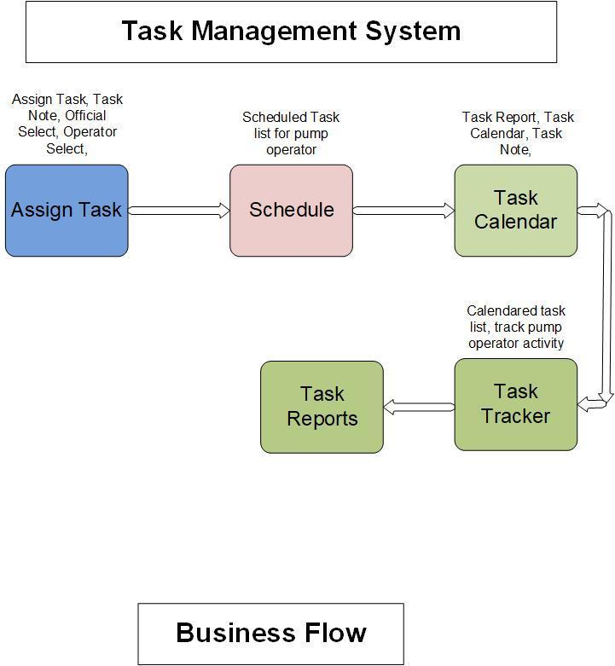

## **Dashboard**

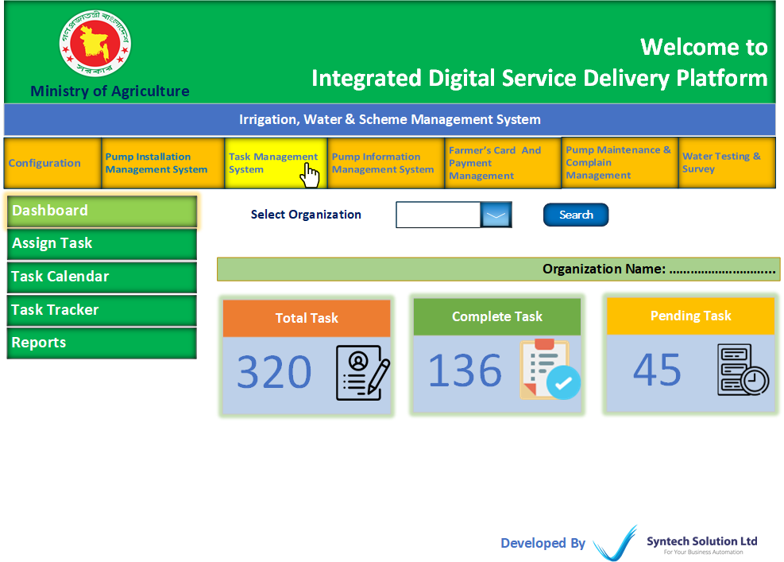

|  |  |  |  |  |  |  |  |  |  |  |  |  |  |  |  |  |  |  |  |  |  |  |  |  |  |  |  |  |  |  |  |  |  |  |  |  |  |  |  |  |  |  |  |  |  |  |  |  |  |
| --- | --- | --- | --- | --- | --- | --- | --- | --- | --- | --- | --- | --- | --- | --- | --- | --- | --- | --- | --- | --- | --- | --- | --- | --- | --- | --- | --- | --- | --- | --- | --- | --- | --- | --- | --- | --- | --- | --- | --- | --- | --- | --- | --- | --- | --- | --- | --- | --- | --- |
| **Assign Task (Feature)**  * Here user can create a new task for pump operator and officials individually.   Create New Task (Button)   |  |  |  |  | | --- | --- | --- | --- | | Field Name | Data Type | Data Length | Mandatory (Yes/No) | | Organization Name | N/A | N/A | Yes | | Task Name | Varchar | N/A | Yes | | Task for Operator/Officials   * Operator ID/Officials ID | Checkbox | N/A | Yes | | Task Schedule | Date/Time | N/A | Yes | | Task Note | Varchar | N/A | N/A | | Attachment | N/A | N/A | No |  |  |  |  |  |  |  |  |  |  |  |  |  |  |  |  |  |  |  |  |  |  | | --- | --- | --- | --- | --- | --- | --- | --- | --- | --- | --- | --- | --- | --- | --- | --- | --- | --- | --- | --- | --- | | Task List (Table Format)   |  |  |  |  |  |  |  |  |  |  | | --- | --- | --- | --- | --- | --- | --- | --- | --- | --- | | SL No | Task ID | Task Name | Task for | Responsible | Attachment | Task Note | Schedule | Status  (Pending, Complete, Calendared) | Action | | 01 | 002 | maintenance | …… | Arif | Link |  | On Time: 05 am  Off Time: 05 pm | Pending | Verify | | |

|  |  |  |  |  |  |  |  |  |  |  |  |  |  |  |  |  |  |  |  |  |  |  |  |  |  |  |  |  |  |  |  |  |  |  |  |  |  |  |  |  |  |
| --- | --- | --- | --- | --- | --- | --- | --- | --- | --- | --- | --- | --- | --- | --- | --- | --- | --- | --- | --- | --- | --- | --- | --- | --- | --- | --- | --- | --- | --- | --- | --- | --- | --- | --- | --- | --- | --- | --- | --- | --- | --- |
| **Task Calendar (Feature)**  * Here assigned officials will report his/her task.  |  |  |  |  |  |  |  |  |  |  |  |  |  |  |  |  |  |  |  |  |  | | --- | --- | --- | --- | --- | --- | --- | --- | --- | --- | --- | --- | --- | --- | --- | --- | --- | --- | --- | --- | --- | | Task List (Table Format)   |  |  |  |  |  |  |  |  |  |  | | --- | --- | --- | --- | --- | --- | --- | --- | --- | --- | | SL No | Task Id | Task Name | Schedule | Attachment | Task Note | Review Note | Status  (Pending, Complete, Verified) | Task Calendar Date | Action | | 01 | 002 | Maintenance | On Time: 05 am  Off Time: 05 pm | Link |  | Review  (From Task Tracker) | (From Task Tracker) | (From Task Report button) | Task Report  (Button) | |   Task Report (Button)   |  |  |  |  | | --- | --- | --- | --- | | Field Name | Data Type | Data Length | Mandatory (Yes/No) | | Task Completion  (Complete, Partial) | N/A | N/A | Yes | | Attachment | N/A | N/A | No | | Note | N/A | N/A | Yes | | Date | N/A | N/A | Yes | |

|  |  |  |  |  |  |  |  |  |  |  |  |  |  |  |  |  |  |  |  |  |  |  |  |  |  |  |  |  |  |  |  |  |  |  |  |  |
| --- | --- | --- | --- | --- | --- | --- | --- | --- | --- | --- | --- | --- | --- | --- | --- | --- | --- | --- | --- | --- | --- | --- | --- | --- | --- | --- | --- | --- | --- | --- | --- | --- | --- | --- | --- | --- |
| **Task Tracker (Feature)**  * Here can track all task with report, attachment and Note. * User can verify and review every single task.  |  |  |  |  |  |  |  |  |  |  |  |  |  |  |  |  |  |  |  |  |  |  |  |  |  |  |  |  | | --- | --- | --- | --- | --- | --- | --- | --- | --- | --- | --- | --- | --- | --- | --- | --- | --- | --- | --- | --- | --- | --- | --- | --- | --- | --- | --- | --- | | Assigned Task List (Table Format)   |  |  |  |  |  |  |  |  |  |  |  | | --- | --- | --- | --- | --- | --- | --- | --- | --- | --- | --- | | **SL No** | **Task Id** | **Task Name** | **Responsible** | **Attachment** | **Schedule** | **Task Report** | | | | | | **Status (Partial, Complete)** | **Attachment** | **Note** | **Calendar Date** | **Action** | | 01 | 002 | Maintenance | Arif | Link |  | Partial | Link |  | On Time: 05 am  Off Time: 05 pm | Verify (Button),  Review, (Button) | |   Review (Button)   |  |  |  |  | | --- | --- | --- | --- | | Field Name | Data Type | Data Length | Mandatory (Yes/No) | | Review Note | Varchar | N/A | Yes | |

|  |  |  |  |  |  |  |  |  |  |  |  |  |  |  |  |  |  |  |  |  |  |  |  |  |  |  |  |  |  |  |  |  |  |  |  |  |  |  |  |  |  |  |  |  |  |  |  |  |  |  |  |  |
| --- | --- | --- | --- | --- | --- | --- | --- | --- | --- | --- | --- | --- | --- | --- | --- | --- | --- | --- | --- | --- | --- | --- | --- | --- | --- | --- | --- | --- | --- | --- | --- | --- | --- | --- | --- | --- | --- | --- | --- | --- | --- | --- | --- | --- | --- | --- | --- | --- | --- | --- | --- | --- |
| **Reports (Feature)**  * User can search for any report.  |  |  |  |  | | --- | --- | --- | --- | | Task Status Report | | | | | Field Name | Data Type | Data Length | Mandatory (Yes/No) | | Organization | N/A | N/A | No | | Task ID | Varchar | N/A | No | | Task Status | N/A | N/A | No | | Date From | Date | N/A | No | | Date To | Date | N/A | No |   Task Status Report (Table Format)   |  |  |  |  |  |  |  |  |  |  | | --- | --- | --- | --- | --- | --- | --- | --- | --- | --- | | **SL No** | **Task Id** | **Task Name** | **Responsible** | **Attachment** | **Schedule** | **Task Report** | | | | | **Status (Partial, Complete)** | **Attachment** | **Note** | **Calendar Date** | | 01 | 002 | Maintenance | Arif | Link | On Time: 05 am  Off Time: 05 pm | Partial | Link |  | On Time: 05 am  Off Time: 05 pm | |

# **Pump Information Management System**

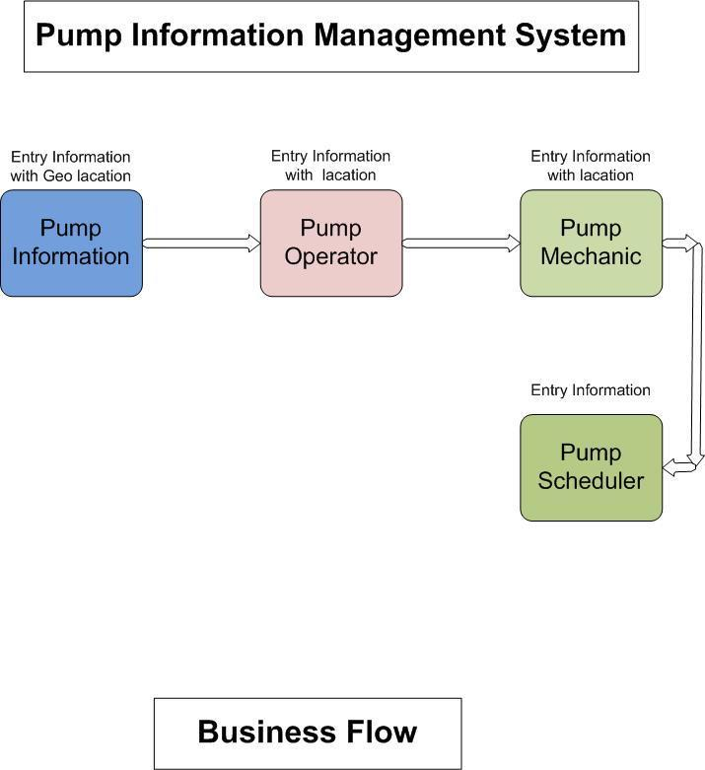

## **Dashboard**

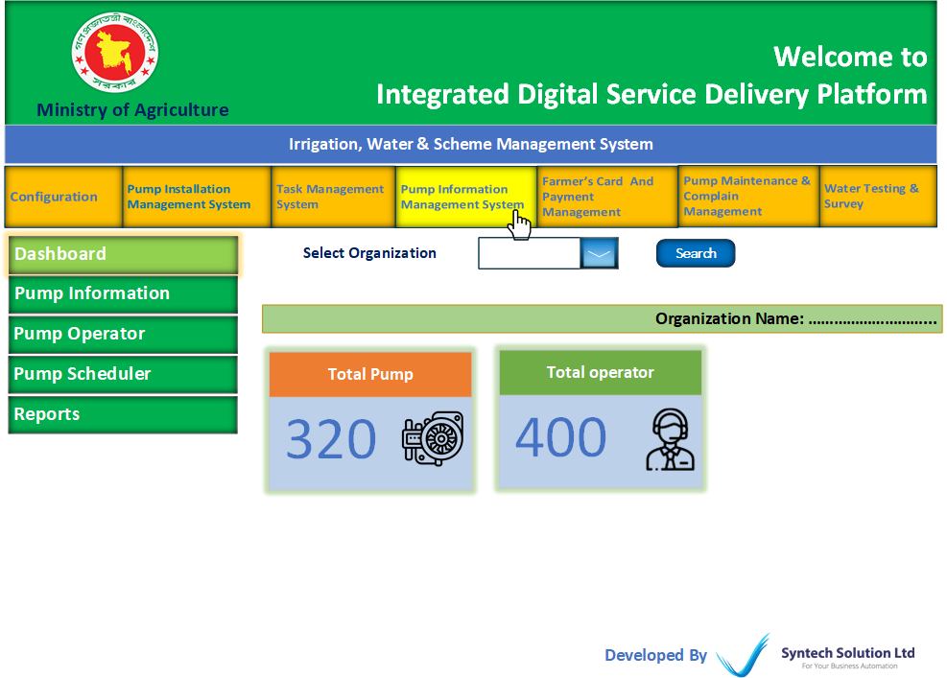

|  |  |  |  |  |  |  |  |  |  |  |  |  |  |  |  |  |  |  |  |  |  |  |  |  |  |  |  |  |  |  |  |  |  |  |  |  |  |  |  |  |  |  |  |  |  |  |  |  |  |  |  |  |  |  |  |  |
| --- | --- | --- | --- | --- | --- | --- | --- | --- | --- | --- | --- | --- | --- | --- | --- | --- | --- | --- | --- | --- | --- | --- | --- | --- | --- | --- | --- | --- | --- | --- | --- | --- | --- | --- | --- | --- | --- | --- | --- | --- | --- | --- | --- | --- | --- | --- | --- | --- | --- | --- | --- | --- | --- | --- | --- | --- |
| **Pump Information (Feature)**  * Here is entry field of pump information with GEO Location   Add New Pump (Button)   |  |  |  |  | | --- | --- | --- | --- | | Field Name | Data Type | Data Length | Mandatory (Yes/No) | | Organization | Varchar | N/A | Yes | | Pump ID | Int | N/A | Yes | | Select Project | Varchar | N/A | No | | Division | N/A | N/A | Yes | | District | N/A | N/A | Yes | | Upazila | N/A | N/A | Yes | | Union | N/A | N/A | Yes | | Mouza | Varchar | N/A | Yes | | JL No | Varchar | N/A | Yes | | Plot No | Varchar | N/A | Yes | | Water user group name/Id | Varchar | N/A | Yes | | Add GEO Location | vector | N/A | Yes | | Status | N/A | N/A | Yes | |

|  |  |  |  |  |  |  |  |  |  |  |  |  |  |  |  |  |  |  |  |  |  |  |  |  |  |  |  |  |  |  |  |  |  |  |  |  |  |  |  |  |  |  |  |  |  |  |  |  |  |  |  |  |  |  |  |  |
| --- | --- | --- | --- | --- | --- | --- | --- | --- | --- | --- | --- | --- | --- | --- | --- | --- | --- | --- | --- | --- | --- | --- | --- | --- | --- | --- | --- | --- | --- | --- | --- | --- | --- | --- | --- | --- | --- | --- | --- | --- | --- | --- | --- | --- | --- | --- | --- | --- | --- | --- | --- | --- | --- | --- | --- | --- |
| **Pump Operator (Feature)**  * Here is entry field of Pump Operator of Pump Operator   Add Pump Operator (Button)   |  |  |  |  | | --- | --- | --- | --- | | Field Name | Data Type | Data Length | Mandatory (Yes/No) | | Pump ID | Int | N/A | Yes | | Operator Name | Varchar | N/A | Yes | | Father name | Varchar | N/A | Yes | | Mother Name | Varchar | N/A | Yes | | NID | Int | N/A | Yes | | Division | N/A | N/A | Yes | | District | N/A | N/A | Yes | | Upazila | N/A | N/A | Yes | | Union | N/A | N/A | Yes | | Village | Varchar | N/A | Yes | | Mobile No | Int | N/A | Yes | | Email Address | Varchar | N/A | No | | Add GEO Location | vector | N/A | Yes | |

|  |  |  |  |  |  |  |  |  |  |  |  |  |  |  |  |  |  |  |  |  |  |  |  |  |  |  |  |  |  |  |  |  |  |  |  |  |  |  |  |  |  |  |  |  |
| --- | --- | --- | --- | --- | --- | --- | --- | --- | --- | --- | --- | --- | --- | --- | --- | --- | --- | --- | --- | --- | --- | --- | --- | --- | --- | --- | --- | --- | --- | --- | --- | --- | --- | --- | --- | --- | --- | --- | --- | --- | --- | --- | --- | --- |
| **Pump Scheduler (Feature)**  * Here user can on/off schedule for individual pump.   Pump Scheduler (Button)   |  |  |  |  | | --- | --- | --- | --- | | Field Name | Data Type | Data Length | Mandatory (Yes/No) | | Division | N/A | N/A | Yes | | District | N/A | N/A | Yes | | Upazilla | N/A | N/A | Yes | | Union | N/A | N/A | Yes | | Mouza | Varchar | N/A | Yes | | JL No | Varchar | N/A | Yes | | Plot No | Varchar | N/A | Yes | | Search Pump ID | N/A | N/A | Yes | | Pump On Time | Time picker | N/A | Yes | | Pump Off Time | Time picker | N/A | Yes | |

|  |  |  |  |  |  |  |  |  |  |  |  |  |  |  |  |  |  |  |  |  |  |  |  |  |  |  |  |  |  |  |  |  |  |  |  |  |  |  |  |  |  |  |  |  |  |  |  |  |  |  |  |  |  |  |  |  |  |  |  |  |  |  |  |  |  |  |  |  |  |  |  |  |  |  |  |  |  |  |  |  |  |  |  |  |  |  |  |  |  |  |  |  |  |  |  |  |  |  |  |  |  |  |  |  |  |  |  |  |  |  |  |  |  |  |  |  |  |  |  |  |  |  |  |  |
| --- | --- | --- | --- | --- | --- | --- | --- | --- | --- | --- | --- | --- | --- | --- | --- | --- | --- | --- | --- | --- | --- | --- | --- | --- | --- | --- | --- | --- | --- | --- | --- | --- | --- | --- | --- | --- | --- | --- | --- | --- | --- | --- | --- | --- | --- | --- | --- | --- | --- | --- | --- | --- | --- | --- | --- | --- | --- | --- | --- | --- | --- | --- | --- | --- | --- | --- | --- | --- | --- | --- | --- | --- | --- | --- | --- | --- | --- | --- | --- | --- | --- | --- | --- | --- | --- | --- | --- | --- | --- | --- | --- | --- | --- | --- | --- | --- | --- | --- | --- | --- | --- | --- | --- | --- | --- | --- | --- | --- | --- | --- | --- | --- | --- | --- | --- | --- | --- | --- | --- | --- | --- | --- | --- | --- |
| **Reports (Feature)**  * Here user can search reports.  |  |  |  |  | | --- | --- | --- | --- | | Pump Report | | | | | Field Name | Data Type | Data Length | Mandatory (Yes/No) | | Organization | N/A | N/A | No | | Division | N/A | N/A | Yes | | District | N/A | N/A | No | | Upazila | N/A | N/A | No | | Union | N/A | N/A | No | | Union | N/A | N/A | Yes | | Mouza | Varchar | N/A | Yes | | JL No | Varchar | N/A | Yes | | Plot No | Varchar | N/A | Yes | | Pump ID | N/A | N/A | No | | Search | | | |  |  |  |  |  |  |  | | --- | --- | --- | --- | --- | --- | | Pump Report (Report Format) | | | | | | | SL | Pump ID | Pump Location | Pump Location | Water user group Name/Id | Status | |  |  |  | Link |  |  |  |  |  |  |  | | --- | --- | --- | --- | | Pump Operator Report | | | | | Field Name | Data Type | Data Length | Mandatory (Yes/No) | | Organization | N/A | N/A | N/A | | Division | N/A | N/A | N/A | | District | N/A | N/A | N/A | | Upazila | N/A | N/A | N/A | | Union | N/A | N/A | N/A | | Village | N/A | N/A | N/A | | Pump Operator ID | N/A | N/A | N/A |  |  |  |  |  |  |  | | --- | --- | --- | --- | --- | --- | | Pump Operator Report (Report Format) | | | | | | | SL | Pump Operator ID | Operator Name | Operator Location | Pump Location | Status | |  |  |  | Link |  |  | |

# **Farmer’s Card and Payment Management (Module)**

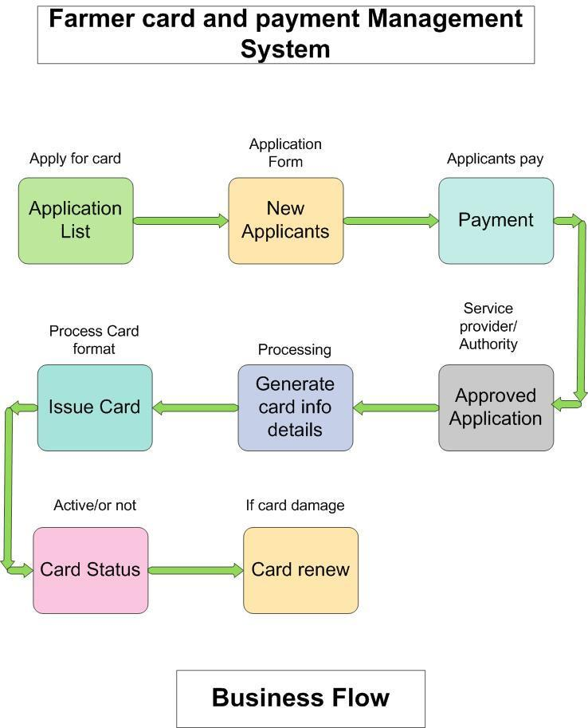

## **Dashboard**

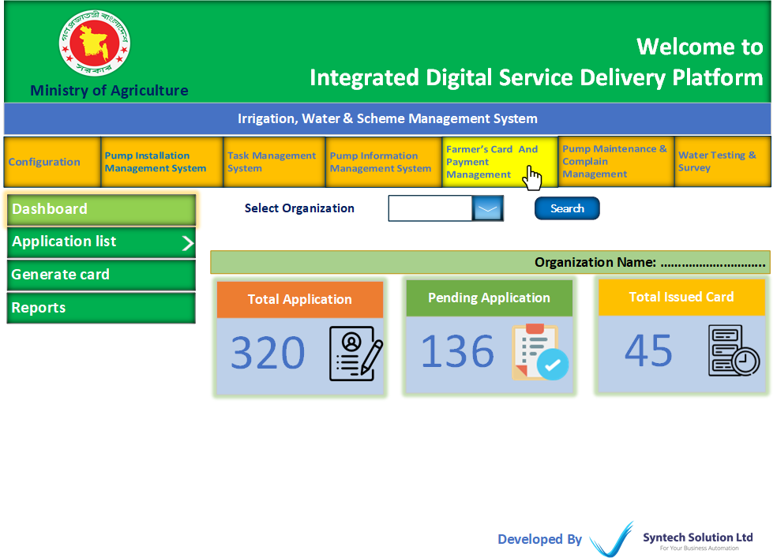

|  |  |  |  |  |  |  |  |  |  |  |  |  |  |  |  |  |  |  |  |  |  |  |  |  |  |  |  |  |  |  |  |  |  |  |  |  |  |  |  |  |  |  |  |  |  |  |  |  |  |  |  |  |  |  |  |  |  |  |  |  |  |  |  |  |  |  |  |  |  |  |  |  |  |  |  |  |  |  |  |  |  |  |  |  |  |  |  |  |
| --- | --- | --- | --- | --- | --- | --- | --- | --- | --- | --- | --- | --- | --- | --- | --- | --- | --- | --- | --- | --- | --- | --- | --- | --- | --- | --- | --- | --- | --- | --- | --- | --- | --- | --- | --- | --- | --- | --- | --- | --- | --- | --- | --- | --- | --- | --- | --- | --- | --- | --- | --- | --- | --- | --- | --- | --- | --- | --- | --- | --- | --- | --- | --- | --- | --- | --- | --- | --- | --- | --- | --- | --- | --- | --- | --- | --- | --- | --- | --- | --- | --- | --- | --- | --- | --- | --- | --- | --- |
| **Application List (Feature)**  * Here will show all application lists applied from the service receiver panel. * Users can Review, Reject, Approve or present for approval.  |  |  |  |  |  |  |  |  |  |  |  |  |  |  |  |  |  |  |  |  |  |  |  |  |  |  |  |  |  |  |  |  |  |  |  |  |  |  |  |  |  |  |  | | --- | --- | --- | --- | --- | --- | --- | --- | --- | --- | --- | --- | --- | --- | --- | --- | --- | --- | --- | --- | --- | --- | --- | --- | --- | --- | --- | --- | --- | --- | --- | --- | --- | --- | --- | --- | --- | --- | --- | --- | --- | --- | --- | | New application Lists (Sub Feature) (Table Format)   |  |  |  |  |  |  |  |  |  | | --- | --- | --- | --- | --- | --- | --- | --- | --- | | SL No | Application ID | Applicant Name | Address | Application Date | View Application | Attached Document (link) | Status | Action | | 1 |  |  |  |  | View (Button) | link | Pending, Reject, Approved | Review (Button),  Reject (Button),  Approve (Button),  Work Flow (Button) |  |  |  |  |  | | --- | --- | --- | --- | | Review (Button) | | | | | Field Name | Data Type | Data Length | Mandatory (Yes/No) | | Review Note | Varchar | N/A | Yes |  * Review action will show in the Service receiver panel.  |  |  |  |  | | --- | --- | --- | --- | | Reject (Button) | | | | | Field Name | Data Type | Data Length | Mandatory (Yes/No) | | Reject Note | Varchar | N/A | Yes |  * Reject action will show in the Service receiver panel. |  |  | | --- | | Reissue Application Lists (Sub Feature)  * Here will show all Reissue application lists applied from the service receiver panel. * Users can Review, Reject, Approve or present for approval. |   (Table Format)   |  |  |  |  |  |  |  |  |  |  | | --- | --- | --- | --- | --- | --- | --- | --- | --- | --- | | SL No | Application ID | Card No | Applicant Name | Address | Application Date | View Application | Attached Document (link) | Status | Action | | 1 |  |  |  |  |  | View (Button) | link | Pending, Reject, Approved | Review (Button),  Reject (Button),  Approve (Button),  Workflow (Button) |  |  |  |  |  | | --- | --- | --- | --- | | Review (Button) | | | | | Field Name | Data Type | Data Length | Mandatory (Yes/No) | | Review Note | Varchar | N/A | N/A |  * Review action will show in the Service receiver panel.  |  |  |  |  | | --- | --- | --- | --- | | Reject (Button) | | | | | Field Name | Data Type | Data Length | Mandatory (Yes/No) | | Reject Note | Varchar | N/A | Yes |  * Reject action will show in the Service receiver panel. |

|  |  |  |  |  |  |  |  |  |  |  |  |  |  |  |  |  |  |  |  |  |
| --- | --- | --- | --- | --- | --- | --- | --- | --- | --- | --- | --- | --- | --- | --- | --- | --- | --- | --- | --- | --- |
| **Generate Card (Feature)**  * Here will show the approved application list. * System will auto generate cards and show them with links. * Users can issue cards.   Approved Application List (Table Format)   |  |  |  |  |  |  |  |  |  |  | | --- | --- | --- | --- | --- | --- | --- | --- | --- | --- | | SL No | Application ID | Applicant Name | Application Type | Address | View Application | Attached Document (link) | Generated Card | Action | Checkbox | | 1 |  |  |  |  | View (Button) | link | Link | Issue Card (Button) | Select All for issue card one shot | |

|  |  |  |  |  |  |  |  |  |  |  |  |  |  |  |  |  |  |  |  |  |  |  |  |  |  |  |  |  |  |  |  |  |  |  |  |  |  |  |  |  |  |  |  |  |  |  |  |  |  |  |  |  |  |  |  |  |  |  |  |  |  |  |  |  |  |  |  |  |  |  |  |  |  |  |  |  |  |  |  |  |  |  |  |  |  |  |  |  |  |  |  |  |  |  |
| --- | --- | --- | --- | --- | --- | --- | --- | --- | --- | --- | --- | --- | --- | --- | --- | --- | --- | --- | --- | --- | --- | --- | --- | --- | --- | --- | --- | --- | --- | --- | --- | --- | --- | --- | --- | --- | --- | --- | --- | --- | --- | --- | --- | --- | --- | --- | --- | --- | --- | --- | --- | --- | --- | --- | --- | --- | --- | --- | --- | --- | --- | --- | --- | --- | --- | --- | --- | --- | --- | --- | --- | --- | --- | --- | --- | --- | --- | --- | --- | --- | --- | --- | --- | --- | --- | --- | --- | --- | --- | --- | --- | --- | --- | --- |
| **Reports (Feature)**  * User can search reports.  |  |  |  |  | | --- | --- | --- | --- | | Application Report | | | | | Field Name | Data Type | Data Length | Mandatory (Yes/No) | | Organization | N/A | N/A | N/A | | ID | N/A | N/A | N/A | | Application Type | N/A | N/A | N/A | | Status | N/A | N/A | N/A | | Date From | N/A | N/A | N/A | | Date To | N/A | N/A | N/A |   Application Report (Report Format)   |  |  |  |  |  |  |  |  |  | | --- | --- | --- | --- | --- | --- | --- | --- | --- | | SL No | Organization | Application ID | Applicant Name | Application Type | Status | View Application | Attached Document (link) | Generated Card | | 1 |  |  |  |  |  | View (Button) | link | Link |  |  |  |  |  | | --- | --- | --- | --- | | Payment Collection Report | | | | | Field Name | Data Type | Data Length | Mandatory (Yes/No) | | Organization | N/A | N/A | N/A | | ID | N/A | N/A | N/A | | Application Type | N/A | N/A | N/A | | Date From | N/A | N/A | N/A | | Date To | N/A | N/A | N/A |   Payment Collection Report (Report Format)   |  |  |  |  |  |  |  |  | | --- | --- | --- | --- | --- | --- | --- | --- | | SL No | Organization | Payment Type | Amount | Payment Date | Applicant Name | View Application | Attached Document (link) | | 1 |  |  |  |  |  | View (Button) | link | |

# **Pump Maintenance & Complain Management (Module)**

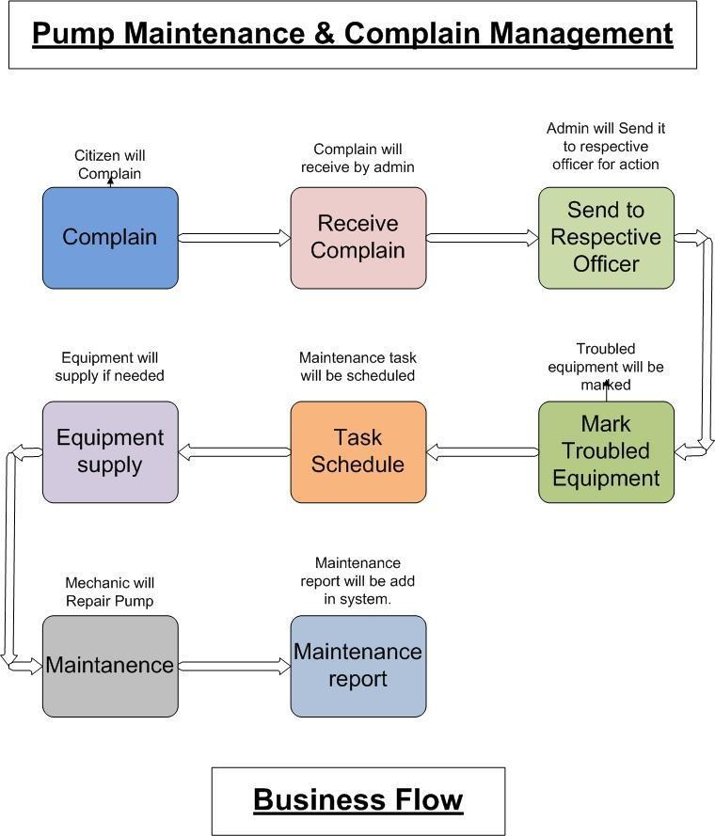

## **Dashboard**

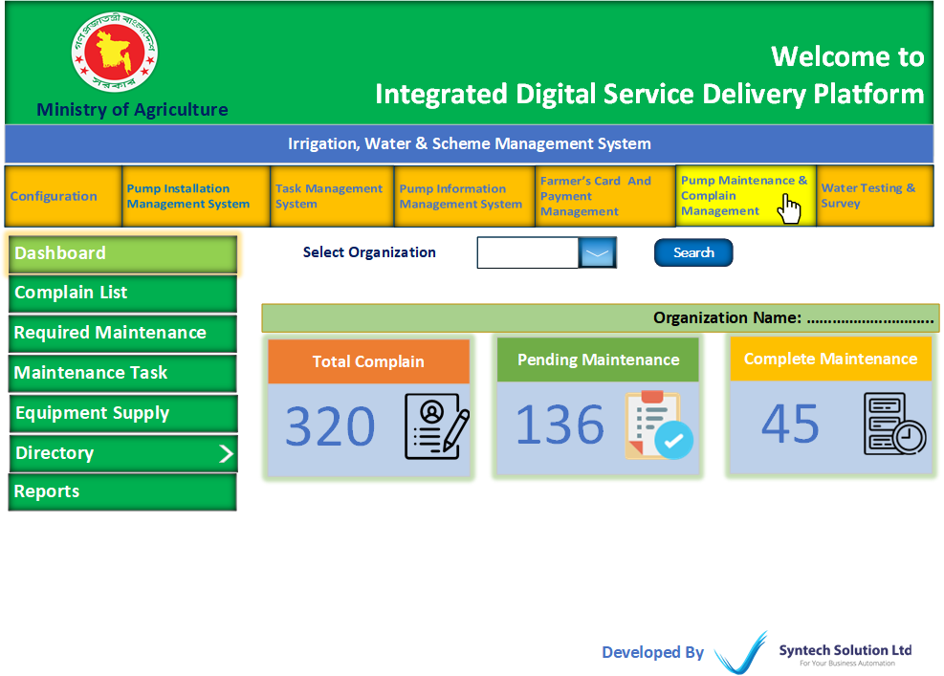

|  |  |  |  |  |  |  |  |  |  |  |  |  |  |  |  |  |  |  |  |  |  |  |  |  |  |  |  |  |  |  |  |  |  |  |  |  |
| --- | --- | --- | --- | --- | --- | --- | --- | --- | --- | --- | --- | --- | --- | --- | --- | --- | --- | --- | --- | --- | --- | --- | --- | --- | --- | --- | --- | --- | --- | --- | --- | --- | --- | --- | --- | --- |
| **Complain List (Feature)**  * Here will show all complain list from service receiver panel * Users can Close, Present and send for maintenance.   Complain List (Table Format)   |  |  |  |  |  |  |  |  |  |  | | --- | --- | --- | --- | --- | --- | --- | --- | --- | --- | | **SL No** | **Organization** | **Complain ID** | **Complained by** | **Location** | **Subject** | **Date** | **View Complain** | **Attachment** | **Action** | |  |  |  |  |  |  |  | View (Button) | Link | Resolved (Button)  Workflow (Button),  Send (Button),  Review (Button) |  * Apply of “Send” Button, the file will go to the “Required Maintenance” (Feature) for farther action.   Resolved (Button)   |  |  |  |  | | --- | --- | --- | --- | | Field Name | Data Type | Data Length | Mandatory (Yes/No) | | Resolve Note | Varchar | N/A | Yes |   Review (Button)   |  |  |  |  | | --- | --- | --- | --- | | Field Name | Data Type | Data Length | Mandatory (Yes/No) | | Review Note | Varchar | N/A | Yes | |

|  |  |  |  |  |  |  |  |  |  |  |  |  |  |  |  |  |  |  |  |  |  |  |  |  |  |  |  |  |  |  |  |  |  |  |  |  |  |  |  |  |  |  |  |  |  |  |  |  |  |  |  |  |  |  |  |  |  |  |  |  |  |  |  |  |  |  |  |  |  |  |  |  |  |  |  |  |  |
| --- | --- | --- | --- | --- | --- | --- | --- | --- | --- | --- | --- | --- | --- | --- | --- | --- | --- | --- | --- | --- | --- | --- | --- | --- | --- | --- | --- | --- | --- | --- | --- | --- | --- | --- | --- | --- | --- | --- | --- | --- | --- | --- | --- | --- | --- | --- | --- | --- | --- | --- | --- | --- | --- | --- | --- | --- | --- | --- | --- | --- | --- | --- | --- | --- | --- | --- | --- | --- | --- | --- | --- | --- | --- | --- | --- | --- | --- |
| **Required Maintenance (Feature)**  * Here will show the Maintenance required list from the complaint list. * Users can close, add troubled equipment & Send for tasks. * This feature is for the person who can get information about troubled equipment and add for maintenance.  |  |  |  |  |  |  |  |  |  |  |  |  |  |  |  |  |  |  |  |  |  | | --- | --- | --- | --- | --- | --- | --- | --- | --- | --- | --- | --- | --- | --- | --- | --- | --- | --- | --- | --- | --- | | Maintenance List (Table Format)   |  |  |  |  |  |  |  |  |  |  | | --- | --- | --- | --- | --- | --- | --- | --- | --- | --- | | **SL No** | **Complain ID** | **Complained by** | **Location** | **Subject** | **Date** | **View Complain** | **Attachment** | **Identified Equipment List** | **Action** | |  |  |  |  |  |  | View (Button) | Link |  | Resolved (Button)  Resink (Button)  Identify Equipment (Button), |  * Apply of “Send for Task” Button, the file will go to “Maintenance Task” Feature for farther action |   Resolved (Button)   |  |  |  |  | | --- | --- | --- | --- | | Field Name | Data Type | Data Length | Mandatory (Yes/No) | | Resolve Note | Varchar | N/A | Yes |   Resink (Button)   |  |  |  |  | | --- | --- | --- | --- | | Field Name | Data Type | Data Length | Mandatory (Yes/No) | | Resink Note | Varchar | N/A | Yes |   Identify Equipment (Button)   |  |  |  |  | | --- | --- | --- | --- | | Field Name | Data Type | Data Length | Mandatory (Yes/No) | | Division  (Address) | Varchar | N/A | Yes | | District  (Address) | Varchar | N/A | Yes | | Upazila  (Address) | Varchar | N/A | Yes | | Union  (Address) | Varchar | N/A | Yes | | J/L No.  (Address) | Varchar | N/A | Yes | | Plot No.  (Address) | Varchar | N/A | Yes | | Equipment Name  (Add Troubled Equipment) | Varchar | N/A | Yes | | Problem Note  (Add Troubled Equipment) +Add More | Varchar | N/A | Yes | | Save as Draft (Button), Send for Task (Button), Close (Button), | | | | |

|  |  |  |  |  |  |  |  |  |  |  |  |  |  |  |  |  |  |  |  |  |  |  |  |  |  |  |  |  |  |  |  |  |  |  |  |  |  |  |  |  |  |  |  |  |  |  |  |  |  |  |  |  |  |  |  |  |  |  |  |  |  |  |  |  |  |  |  |  |  |  |  |  |  |  |  |  |  |  |  |
| --- | --- | --- | --- | --- | --- | --- | --- | --- | --- | --- | --- | --- | --- | --- | --- | --- | --- | --- | --- | --- | --- | --- | --- | --- | --- | --- | --- | --- | --- | --- | --- | --- | --- | --- | --- | --- | --- | --- | --- | --- | --- | --- | --- | --- | --- | --- | --- | --- | --- | --- | --- | --- | --- | --- | --- | --- | --- | --- | --- | --- | --- | --- | --- | --- | --- | --- | --- | --- | --- | --- | --- | --- | --- | --- | --- | --- | --- | --- | --- |
| **Maintenance Task (Feature)**  * Here will show a troubled equipment list that came from Required “Maintenance” Feature. * Users can assign mechanics, update reports, and make requisitions to store.  |  |  |  |  |  |  |  |  |  |  |  |  |  |  |  |  |  |  |  |  |  |  |  | | --- | --- | --- | --- | --- | --- | --- | --- | --- | --- | --- | --- | --- | --- | --- | --- | --- | --- | --- | --- | --- | --- | --- | | Troubled Equipment List (Table Format)   |  |  |  |  |  |  |  |  |  |  |  | | --- | --- | --- | --- | --- | --- | --- | --- | --- | --- | --- | | **SL No** | **ID** | **Identified Equipment** | **Problem Note** | **Pump Location** | **Mechanic Status** | **Maintenance Report** | **Requisition Status** | **Progress Note** | **Assign Mechanic** | **Action** | |  |  |  |  | Link | Assigned,  Not Assigned | Processing,  Complete,  Partial,  Not Done | Supplied,  Pending,  Rejected |  | Assign (Button),  Change, (Button) | Resolved (Button),  Requisition (Button)  Report (Button) |  * After Submission of report, all buttons will be inactive. |   Assign (Button)   |  |  |  |  | | --- | --- | --- | --- | | Field Name | Data Type | Data Length | Mandatory (Yes/No) | | Search Mechanic ID | Int | N/A | Yes |   Assign  Resolved (Button)   |  |  |  |  | | --- | --- | --- | --- | | Field Name | Data Type | Data Length | Mandatory (Yes/No) | | Resolve Note | Varchar | N/A | Yes |   Submit  Requisition (Button)   |  |  |  |  | | --- | --- | --- | --- | | Field Name | Data Type | Data Length | Mandatory (Yes/No) | | Item Name  (Add Requisition) | Varchar | N/A | Yes | | Quantity (Add Requisition) +Add More | Int | N/A | Yes | | Remarks | N/A | N/A | Yes |   Submit  Report (Button)   |  |  |  |  | | --- | --- | --- | --- | | Field Name | Data Type | Data Length | Mandatory (Yes/No) | | Complete  (Progress) | N/A | N/A | N/A | | Partial  (Progress) | N/A | N/A | N/A | | Not Done  (Progress) | N/A | N/A | N/A | | Progress Note | N/A | N/A | N/A | | Date | N/A | N/A | N/A |   Submit |

|  |  |  |  |  |  |  |  |  |  |  |  |  |  |  |  |  |  |  |  |  |  |  |  |  |  |  |  |  |  |  |  |  |  |  |  |  |  |
| --- | --- | --- | --- | --- | --- | --- | --- | --- | --- | --- | --- | --- | --- | --- | --- | --- | --- | --- | --- | --- | --- | --- | --- | --- | --- | --- | --- | --- | --- | --- | --- | --- | --- | --- | --- | --- | --- |
| **Equipment Supply (Feature)**  * Here will show requisition of maintenance hardware. * Storekeeper can supply and reject valid Notes.  |  |  |  |  |  |  |  |  |  |  |  |  |  |  |  |  |  |  |  |  |  |  |  |  |  |  |  |  |  |  |  |  |  |  |  |  |  | | --- | --- | --- | --- | --- | --- | --- | --- | --- | --- | --- | --- | --- | --- | --- | --- | --- | --- | --- | --- | --- | --- | --- | --- | --- | --- | --- | --- | --- | --- | --- | --- | --- | --- | --- | --- | --- | | Requisition List (Table Format)   |  |  |  |  |  |  | | --- | --- | --- | --- | --- | --- | | **SL No** | **Requisition Date** | **Requisition ID** | **Pump location** | **View Requisition** | **Status** | |  |  |  | **Link** | **View (Button)** | **Pending/Partial/Complete** |   View(Button)   |  |  |  |  | | --- | --- | --- | --- | | Field Name | Data Type | Data Length | Mandatory (Yes/No) | | Item Info (Auto) | Varchar | N/A | Yes | | Applied Quantity (Auto) | int | N/A | Yes | | Approved Quantity | int | N/A | Yes | | Shortage Reason | Varchar | N/A | Yes | | Action (Issue/Reject) | N/A | N/A | Yes |   Submit | |

|  |  |  |  |  |  |  |  |  |  |  |  |  |  |  |  |  |  |  |  |  |  |  |  |  |  |  |  |  |  |  |  |  |  |  |  |  |  |  |  |  |  |  |  |  |  |  |  |  |  |  |  |  |  |  |  |  |  |  |  |  |  |  |  |  |  |  |  |  |  |  |  |  |  |  |  |  |  |  |  |  |  |  |  |  |  |  |  |  |  |  |  |  |  |  |  |  |  |  |  |  |  |  |  |  |  |  |  |  |  |  |  |  |  |  |  |  |  |  |  |  |  |  |  |  |  |  |  |  |  |  |  |  |  |  |  |  |  |  |  |  |  |  |  |  |  |  |  |  |  |  |  |  |  |  |  |  |  |  |  |  |  |  |  |  |  |  |  |  |  |  |  |  |  |  |  |  |  |  |  |  |  |  |  |  |  |  |  |  |  |  |  |  |  |  |  |  |  |  |  |  |  |  |  |  |  |  |  |  |  |  |  |  |  |  |  |  |  |  |  |  |  |  |  |  |  |  |  |  |  |  |  |  |  |  |  |  |  |  |  |  |  |  |  |  |  |  |  |  |  |  |  |  |  |  |  |  |  |  |  |  |  |  |  |  |  |  |  |  |  |  |  |
| --- | --- | --- | --- | --- | --- | --- | --- | --- | --- | --- | --- | --- | --- | --- | --- | --- | --- | --- | --- | --- | --- | --- | --- | --- | --- | --- | --- | --- | --- | --- | --- | --- | --- | --- | --- | --- | --- | --- | --- | --- | --- | --- | --- | --- | --- | --- | --- | --- | --- | --- | --- | --- | --- | --- | --- | --- | --- | --- | --- | --- | --- | --- | --- | --- | --- | --- | --- | --- | --- | --- | --- | --- | --- | --- | --- | --- | --- | --- | --- | --- | --- | --- | --- | --- | --- | --- | --- | --- | --- | --- | --- | --- | --- | --- | --- | --- | --- | --- | --- | --- | --- | --- | --- | --- | --- | --- | --- | --- | --- | --- | --- | --- | --- | --- | --- | --- | --- | --- | --- | --- | --- | --- | --- | --- | --- | --- | --- | --- | --- | --- | --- | --- | --- | --- | --- | --- | --- | --- | --- | --- | --- | --- | --- | --- | --- | --- | --- | --- | --- | --- | --- | --- | --- | --- | --- | --- | --- | --- | --- | --- | --- | --- | --- | --- | --- | --- | --- | --- | --- | --- | --- | --- | --- | --- | --- | --- | --- | --- | --- | --- | --- | --- | --- | --- | --- | --- | --- | --- | --- | --- | --- | --- | --- | --- | --- | --- | --- | --- | --- | --- | --- | --- | --- | --- | --- | --- | --- | --- | --- | --- | --- | --- | --- | --- | --- | --- | --- | --- | --- | --- | --- | --- | --- | --- | --- | --- | --- | --- | --- | --- | --- | --- | --- | --- | --- | --- | --- | --- | --- | --- | --- | --- | --- | --- | --- | --- | --- | --- | --- | --- | --- | --- | --- | --- | --- | --- | --- | --- | --- | --- | --- | --- | --- | --- | --- | --- | --- | --- | --- | --- | --- |
| **Directory (Feature)**  * This feature is for only entry purposes. * Users can enter, delete and edit. * List with show district wise.  |  |  |  |  |  |  |  |  |  |  |  |  |  |  |  |  |  |  |  |  |  |  |  |  |  |  |  |  |  |  |  |  |  |  |  |  |  |  |  |  |  |  |  |  |  |  |  |  |  |  |  |  |  |  |  |  |  |  |  |  |  |  |  |  |  |  |  |  |  |  |  |  |  |  |  |  |  |  |  |  |  |  |  |  |  |  |  |  |  | | --- | --- | --- | --- | --- | --- | --- | --- | --- | --- | --- | --- | --- | --- | --- | --- | --- | --- | --- | --- | --- | --- | --- | --- | --- | --- | --- | --- | --- | --- | --- | --- | --- | --- | --- | --- | --- | --- | --- | --- | --- | --- | --- | --- | --- | --- | --- | --- | --- | --- | --- | --- | --- | --- | --- | --- | --- | --- | --- | --- | --- | --- | --- | --- | --- | --- | --- | --- | --- | --- | --- | --- | --- | --- | --- | --- | --- | --- | --- | --- | --- | --- | --- | --- | --- | --- | --- | --- | --- | | Hardware Dealer (Sub Feature) Add New Hardware Dealer (Button)   |  |  |  |  | | --- | --- | --- | --- | | Field Name | Data Type | Data Length | Mandatory (Yes/No) | | Hardware Dealer Name | Varchar | N/A | Yes | | Select Equipment Category  (Add More)+ | N/A | N/A | Yes | | Hardware Details (Text Box)+ | Varchar | N/A | Yes | | Division  (Dealer Address) | N/A | N/A | Yes | | District  (Dealer Address) | N/A | N/A | Yes | | Upazila  (Dealer Address) | N/A | N/A | Yes | | Union  (Dealer Address) | N/A | N/A | Yes | | Village | Varchar | N/A | Yes | | Add GEO Location (Map) | Map | N/A | Yes | | Address Line  (Dealer Address) | Varchar | N/A | Yes | | Mobile No | int | N/A | Yes | | Email Address | Varchar | N/A | No | | Attach Photo | N/A | N/A | No | | Document Name  (Attach Document) | Varchar | N/A | No | | Upload  (Attach Document)+ Add More | N/A | N/A | No |   Submit  Hardware Dealer List(Table Format)   |  |  |  |  |  |  |  |  |  |  |  |  | | --- | --- | --- | --- | --- | --- | --- | --- | --- | --- | --- | --- | | SL No | Dealer ID | Dealer Name | Equipment Category | Hardware Details | Address Line | District | Mobile No | Email | Location | Attachment | Action | |  |  |  |  |  |  |  |  |  | Link | Link | Edit,  Delete | |  |  |  |  |  |  |  |  |  |  |  |  |  |  |  |  |  |  |  |  |  |  |  |  |  |  |  |  |  |  |  |  |  |  |  |  |  |  |  |  |  |  |  |  |  |  |  |  |  |  |  |  |  |  |  |  |  |  |  |  |  |  |  |  |  |  |  |  |  |  |  |  |  |  |  |  |  |  |  |  |  |  |  |  |  |  |  |  |  |  | | --- | --- | --- | --- | --- | --- | --- | --- | --- | --- | --- | --- | --- | --- | --- | --- | --- | --- | --- | --- | --- | --- | --- | --- | --- | --- | --- | --- | --- | --- | --- | --- | --- | --- | --- | --- | --- | --- | --- | --- | --- | --- | --- | --- | --- | --- | --- | --- | --- | --- | --- | --- | --- | --- | --- | --- | --- | --- | --- | --- | --- | --- | --- | --- | --- | --- | --- | --- | --- | --- | --- | --- | --- | --- | --- | --- | --- | --- | --- | --- | --- | --- | --- | --- | --- | --- | --- | --- | --- | | Shops (Sub Feature) Add New Shop (Button)   |  |  |  |  | | --- | --- | --- | --- | | Field Name | Data Type | Data Length | Mandatory (Yes/No) | | Shop Name | Varchar | N/A | Yes | | Select Equipment Category (Add More)+ | N/A | N/A | Yes | | Product Details (Text Box)+ | Varchar | N/A | Yes | | Division  (Shop Address) | N/A | N/A | Yes | | District  (Shop Address) | N/A | N/A | Yes | | Upazila  (Shop Address) | N/A | N/A | Yes | | Union  (Shop Address) | N/A | N/A | Yes | | Add GEO Location (Map) | vector | N/A | Yes | | Address Line  (Shop Address) | Varchar | N/A | No | | Mobile No | int | N/A | Yes | | Email Address | Varchar | N/A | Yes | | Attach Photo | N/A | N/A | No | | Document Name  (Attach Document) | Varchar | N/A | No | | Upload  (Attach Document) | N/A | N/A | No | | Add More  (Attach Document) | N/A | N/A | No |   Submit  Shop List(Table Format)   |  |  |  |  |  |  |  |  |  |  |  |  | | --- | --- | --- | --- | --- | --- | --- | --- | --- | --- | --- | --- | | SL No | Shop ID | Shop Name | Equipment Category | Address Line | District | Product Details | Mobile No | Email | Location | Attachment | Action | |  |  |  |  |  |  |  |  |  | Link | Link | Edit,  Delete | |  |  |  |  |  |  |  |  |  |  |  |  |  |  |  |  |  |  |  |  |  |  |  |  |  |  |  |  |  |  |  |  |  |  |  |  |  |  |  |  |  |  |  |  |  |  |  |  |  |  |  |  |  |  |  |  |  |  |  |  |  |  |  |  |  |  |  |  |  |  |  |  |  |  |  |  |  |  |  |  |  |  |  |  |  |  |  |  |  |  |  |  |  |  | | --- | --- | --- | --- | --- | --- | --- | --- | --- | --- | --- | --- | --- | --- | --- | --- | --- | --- | --- | --- | --- | --- | --- | --- | --- | --- | --- | --- | --- | --- | --- | --- | --- | --- | --- | --- | --- | --- | --- | --- | --- | --- | --- | --- | --- | --- | --- | --- | --- | --- | --- | --- | --- | --- | --- | --- | --- | --- | --- | --- | --- | --- | --- | --- | --- | --- | --- | --- | --- | --- | --- | --- | --- | --- | --- | --- | --- | --- | --- | --- | --- | --- | --- | --- | --- | --- | --- | --- | --- | --- | --- | --- | --- | | Mechanics (Sub Feature) Add New Mechanic (Button)   |  |  |  |  | | --- | --- | --- | --- | | Field Name | Data Type | Data Length | Mandatory (Yes/No) | | Mechanic Name | Varchar | N/A | Yes | | Select Equipment Category (Add More) | N/A | N/A | Yes | | Mechanic Details (Text Box) | Varchar | N/A | Yes | | Division  (Mechanic’s Address) | N/A | N/A | Yes | | District  (Mechanic’s Address) | N/A | N/A | Yes | | Upazila  (Mechanic’s Address) | N/A | N/A | Yes | | Union  (Mechanic’s Address) | N/A | N/A | Yes | | Village  (Mechanic’s Address) | Varchar | N/A | No | | Address Line  (Mechanic’s Address) | Varchar | N/A | No | | Add GEO Location (Map) | Map | N/A | Yes | | Mobile No | int | N/A | Yes | | Email Address | Varchar | N/A | Yes | | Attach Photo | N/A | N/A | Yes | | Document Name  (Attach Document) | Varchar | N/A | No | | Upload  (Attach Document) | N/A | N/A | No | | Add More  (Attach Document) | N/A | N/A | No |   Submit  Mechanic List(Table Format)   |  |  |  |  |  |  |  |  |  |  |  |  | | --- | --- | --- | --- | --- | --- | --- | --- | --- | --- | --- | --- | | SL No | Mechanic’s ID | Mechanic Name | Equipment Category | Mechanic Details | Address Line | District | Mobile No | Email | Location | Attachment | Action | |  |  |  |  |  |  |  |  |  | Link | Link | Edit,  Delete | | |

|  |  |  |  |  |  |  |  |  |  |  |  |  |  |  |  |  |  |  |  |  |  |  |  |  |  |  |  |  |  |  |  |  |  |  |  |  |  |  |  |  |  |  |  |  |  |  |  |  |  |  |  |  |  |  |  |  |  |  |  |  |  |  |  |  |  |  |  |  |  |  |  |  |  |  |  |  |  |  |  |  |  |  |  |  |  |  |  |  |  |  |  |  |  |  |  |  |  |  |  |  |  |  |  |  |  |  |  |  |  |  |  |  |  |  |  |  |  |  |  |  |  |  |  |  |  |  |  |  |  |  |  |  |  |  |  |  |  |  |  |  |  |  |  |  |  |  |  |  |  |  |  |  |  |  |  |  |  |  |  |  |
| --- | --- | --- | --- | --- | --- | --- | --- | --- | --- | --- | --- | --- | --- | --- | --- | --- | --- | --- | --- | --- | --- | --- | --- | --- | --- | --- | --- | --- | --- | --- | --- | --- | --- | --- | --- | --- | --- | --- | --- | --- | --- | --- | --- | --- | --- | --- | --- | --- | --- | --- | --- | --- | --- | --- | --- | --- | --- | --- | --- | --- | --- | --- | --- | --- | --- | --- | --- | --- | --- | --- | --- | --- | --- | --- | --- | --- | --- | --- | --- | --- | --- | --- | --- | --- | --- | --- | --- | --- | --- | --- | --- | --- | --- | --- | --- | --- | --- | --- | --- | --- | --- | --- | --- | --- | --- | --- | --- | --- | --- | --- | --- | --- | --- | --- | --- | --- | --- | --- | --- | --- | --- | --- | --- | --- | --- | --- | --- | --- | --- | --- | --- | --- | --- | --- | --- | --- | --- | --- | --- | --- | --- | --- | --- | --- | --- | --- | --- | --- | --- | --- | --- | --- | --- | --- | --- | --- | --- | --- | --- | --- |
| **Reports (Feature)**  * User can search reports.  |  |  |  |  | | --- | --- | --- | --- | | Complain Report (Searching Parameter) | | | | | Field Name | Data Type | Data Length | Mandatory (Yes/No) | | Organization | N/A | N/A | No | | Division | N/A | N/A | No | | District | N/A | N/A | No | | Upazila | N/A | N/A | No | | Union | N/A | N/A | No | | Status (Closed/Complete/Processing) | N/A | N/A | No | | From Date | N/A | N/A | No | | To Date | N/A | N/A | No |   Search  Complain Report (Report Format)   |  |  |  |  |  |  |  |  |  |  | | --- | --- | --- | --- | --- | --- | --- | --- | --- | --- | | SL No | Complain id | Complainer Name | Complain Date | Location | Details | Status | View Complain | Attachment | Notes | |  |  |  |  |  |  |  | Link | Link | (From Action) |  |  |  |  |  | | --- | --- | --- | --- | | Maintenance Report (Searching Parameter) | | | | | Field Name | Data Type | Data Length | Mandatory (Yes/No) | | Organization | N/A | N/A | No | | Division | N/A | N/A | No | | District | N/A | N/A | No | | Upazila | N/A | N/A | No | | Union | N/A | N/A | No | | Status  (Closed/Processing/Complete) | N/A | N/A | No | | From Date | N/A | N/A | No | | To Date | N/A | N/A | No |   Search  Maintenance Report (Report Format)   |  |  |  |  |  |  |  | | --- | --- | --- | --- | --- | --- | --- | | SL No | Maintenance id | Assigned Mechanic | Assigned Date | Location | Notes | Maintenance Status | |  |  |  |  |  |  |  |  |  |  |  |  | | --- | --- | --- | --- | | Rating & Feedback Report (Searching Parameter) | | | | | Field Name | Data Type | Data Length | Mandatory (Yes/No) | | Organization | N/A | N/A | No | | Division | N/A | N/A | No | | District | N/A | N/A | No | | Upazila | N/A | N/A | No | | From Date | N/A | N/A | No | | To Date | N/A | N/A | No |   Search  Rating & Feedback Report (Report Format)   |  |  |  |  |  |  |  | | --- | --- | --- | --- | --- | --- | --- | | SL No | Organization | Rated By | District | Rating | Feedback | Date | |  |  |  |  |  |  |  | |

# **Water Testing & Survey (Module)**

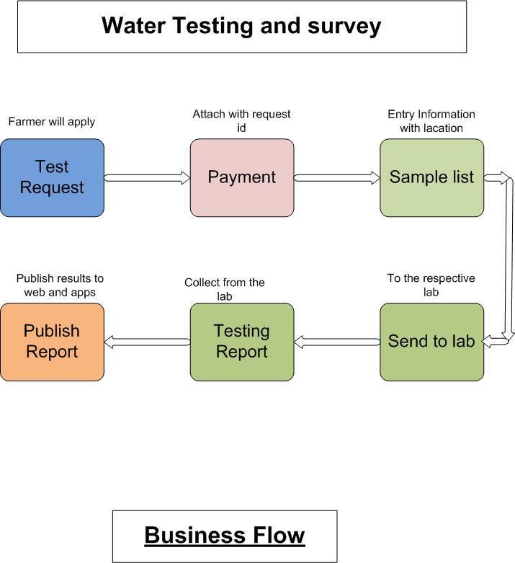

## **Dashboard**

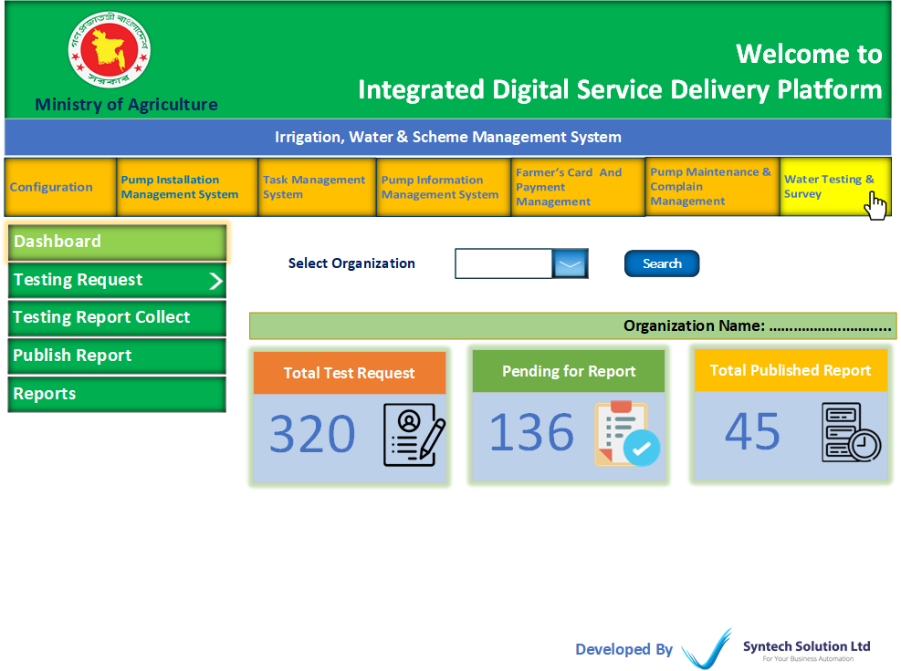

|  |  |  |  |  |  |  |  |  |  |  |  |  |  |  |  |  |  |  |  |  |  |  |  |  |  |  |  |  |  |  |  |  |  |  |  |  |  |  |  |  |  |  |  |  |  |  |  |  |  |  |  |  |  |  |  |  |  |  |  |  |  |  |  |  |  |  |  |  |  |  |  |  |  |  |  |  |  |  |  |  |  |  |  |  |  |  |  |  |  |  |  |  |  |  |  |  |  |  |  |  |  |  |  |  |  |  |  |  |  |  |  |  |  |  |  |  |  |  |  |  |  |  |  |
| --- | --- | --- | --- | --- | --- | --- | --- | --- | --- | --- | --- | --- | --- | --- | --- | --- | --- | --- | --- | --- | --- | --- | --- | --- | --- | --- | --- | --- | --- | --- | --- | --- | --- | --- | --- | --- | --- | --- | --- | --- | --- | --- | --- | --- | --- | --- | --- | --- | --- | --- | --- | --- | --- | --- | --- | --- | --- | --- | --- | --- | --- | --- | --- | --- | --- | --- | --- | --- | --- | --- | --- | --- | --- | --- | --- | --- | --- | --- | --- | --- | --- | --- | --- | --- | --- | --- | --- | --- | --- | --- | --- | --- | --- | --- | --- | --- | --- | --- | --- | --- | --- | --- | --- | --- | --- | --- | --- | --- | --- | --- | --- | --- | --- | --- | --- | --- | --- | --- | --- | --- | --- | --- | --- |
| **Testing Request (Feature)**  * Here will show all water testing requests applied from the service receiver panel. * Users can review, reject, & send samples to the lab after the service receiver presents the sample. * Status will be pending until any action.  |  |  |  |  |  |  |  |  |  |  |  |  |  |  |  |  |  |  |  |  |  |  |  |  |  |  |  |  |  |  |  |  |  |  |  |  |  |  |  |  |  |  |  |  |  |  |  |  |  |  |  |  |  |  |  |  |  |  |  |  |  | | --- | --- | --- | --- | --- | --- | --- | --- | --- | --- | --- | --- | --- | --- | --- | --- | --- | --- | --- | --- | --- | --- | --- | --- | --- | --- | --- | --- | --- | --- | --- | --- | --- | --- | --- | --- | --- | --- | --- | --- | --- | --- | --- | --- | --- | --- | --- | --- | --- | --- | --- | --- | --- | --- | --- | --- | --- | --- | --- | --- | --- | | Irrigation water (Sub Feature) Request List (Table Format)   |  |  |  |  |  |  |  |  |  |  | | --- | --- | --- | --- | --- | --- | --- | --- | --- | --- | | SL No | Application ID | Applicant Name | Address | Application Date | View Application | Sample Number | Status | Payment Status | Action | | 1 |  |  |  |  | View (Button) |  | Pending, Reject,  Reviewed, |  | Send Sample (Button),  Review (Button),  Reject (Button), |  |  |  |  |  | | --- | --- | --- | --- | | Send Sample (Button) | | | | | Field Name | Data Type | Data Length | Mandatory (Yes/No) | | Select Lab (Drop Down) | N/A | N/A | Yes | | Note | Varchar | N/A | No |  |  |  |  |  | | --- | --- | --- | --- | | Review (Button) | | | | | Field Name | Data Type | Data Length | Mandatory (Yes/No) | | Review Note | Varchar | N/A | Yes |  * Review action will appear in the applicant panel.  |  |  |  |  | | --- | --- | --- | --- | | Reject (Button) | | | | | Field Name | Data Type | Data Length | Mandatory (Yes/No) | | Reject Note | Varchar | N/A | Yes | |  * Reject action will appear in the applicant panel.          |  | | --- | | Drinking Water (Sub Feature) |  |  |  |  |  |  |  |  |  |  |  |  |  |  |  |  |  |  |  |  |  |  |  |  |  |  |  |  |  |  |  |  |  |  |  |  |  |  |  |  |  |  |  |  |  |  |  |  |  |  |  |  |  |  |  |  |  |  |  |  |  |  | | --- | --- | --- | --- | --- | --- | --- | --- | --- | --- | --- | --- | --- | --- | --- | --- | --- | --- | --- | --- | --- | --- | --- | --- | --- | --- | --- | --- | --- | --- | --- | --- | --- | --- | --- | --- | --- | --- | --- | --- | --- | --- | --- | --- | --- | --- | --- | --- | --- | --- | --- | --- | --- | --- | --- | --- | --- | --- | --- | --- | --- | | Request List (Table Format)   |  |  |  |  |  |  |  |  |  |  | | --- | --- | --- | --- | --- | --- | --- | --- | --- | --- | | SL No | Application ID | Applicant Name | Address | Application Date | View Application | Sample Number | Status | Payment Status | Action | |  |  |  |  |  | View (Button) |  | Pending, Reject,  Reviewed, |  | Send Sample (Button),  Review (Button),  Reject (Button), |  |  |  |  |  | | --- | --- | --- | --- | | Send Sample (Button) | | | | | Field Name | Data Type | Data Length | Mandatory (Yes/No) | | Select Lab (Drop Down) | N/A | N/A | Yes | | Note | Varchar | N/A | No |  |  |  |  |  | | --- | --- | --- | --- | | Review (Button) | | | | | Field Name | Data Type | Data Length | Mandatory (Yes/No) | | Review Note | Varchar | N/A | Yes |  |  |  |  |  | | --- | --- | --- | --- | | Reject (Button) | | | | | Field Name | Data Type | Data Length | Mandatory (Yes/No) | | Reject Note | Varchar | N/A | Yes | | |

|  |
| --- |
| Industrial Water (Sub Feature) |

|  |  |  |  |  |  |  |  |  |  |  |  |  |  |  |  |  |  |  |  |  |  |  |  |  |  |  |  |  |  |  |  |  |  |  |  |  |  |  |  |  |  |  |  |  |  |  |  |  |  |  |  |  |  |  |  |  |  |  |  |  |
| --- | --- | --- | --- | --- | --- | --- | --- | --- | --- | --- | --- | --- | --- | --- | --- | --- | --- | --- | --- | --- | --- | --- | --- | --- | --- | --- | --- | --- | --- | --- | --- | --- | --- | --- | --- | --- | --- | --- | --- | --- | --- | --- | --- | --- | --- | --- | --- | --- | --- | --- | --- | --- | --- | --- | --- | --- | --- | --- | --- | --- |
| Request List (Table Format)   |  |  |  |  |  |  |  |  |  |  | | --- | --- | --- | --- | --- | --- | --- | --- | --- | --- | | SL No | Application ID | Applicant Name | Address | Application Date | View Application | Sample Number | Status | Payment Status | Action | |  |  |  |  |  | View (Button) |  | Pending, Reject,  Reviewed, |  | Send Sample (Button),  Review (Button),  Reject (Button), |  |  |  |  |  | | --- | --- | --- | --- | | Send Sample (Button) | | | | | Field Name | Data Type | Data Length | Mandatory (Yes/No) | | Select Lab (Drop Down) | N/A | N/A | Yes | | Note | Varchar | N/A | No |  |  |  |  |  | | --- | --- | --- | --- | | Review (Button) | | | | | Field Name | Data Type | Data Length | Mandatory (Yes/No) | | Review Note | Varchar | N/A | Yes |  |  |  |  |  | | --- | --- | --- | --- | | Reject (Button) | | | | | Field Name | Data Type | Data Length | Mandatory (Yes/No) | | Reject Note | Varchar | N/A | Yes | |

|  |  |  |  |  |  |  |  |  |  |  |  |  |  |  |  |  |  |  |  |  |  |  |  |  |  |  |  |  |  |  |  |
| --- | --- | --- | --- | --- | --- | --- | --- | --- | --- | --- | --- | --- | --- | --- | --- | --- | --- | --- | --- | --- | --- | --- | --- | --- | --- | --- | --- | --- | --- | --- | --- |
| **Testing Report Collection (Feature)**  * Here will show all pending sample lists waiting for a report from the lab. * Users can enter a report with report number and attachment after getting a report from the lab.  |  |  |  |  |  |  |  |  |  |  |  |  |  |  |  |  |  |  |  | | --- | --- | --- | --- | --- | --- | --- | --- | --- | --- | --- | --- | --- | --- | --- | --- | --- | --- | --- | | Pending Report List (Table Format)   |  |  |  |  |  |  |  |  |  | | --- | --- | --- | --- | --- | --- | --- | --- | --- | | **SL No** | **Application Id** | **Applicant’s Name** | **Address** | **Responsible Lab** | **Application Type** | **Sample Number** | **Status** | **Action** | |  |  |  |  |  | Irrigation, Drinking,  Industrial |  |  | Attach Report (Button) | |   Collect Report (Button)   |  |  |  |  | | --- | --- | --- | --- | | Field Name | Data Type | Data Length | Mandatory (Yes/No) | | Report Memo No | Varchar | N/A | Yes | | Attach Report File | N/A | N/A | Yes | |

|  |  |  |  |  |  |  |  |  |  |  |  |  |  |  |  |  |  |  |  |  |  |
| --- | --- | --- | --- | --- | --- | --- | --- | --- | --- | --- | --- | --- | --- | --- | --- | --- | --- | --- | --- | --- | --- |
| **Publish water Testing Report (Feature)**  * Here users can publish all collected reports. * Service receivers will get a report after publishing from here.  |  |  |  |  |  |  |  |  |  |  |  |  |  |  |  |  |  |  |  |  |  | | --- | --- | --- | --- | --- | --- | --- | --- | --- | --- | --- | --- | --- | --- | --- | --- | --- | --- | --- | --- | --- | | Collected Report (Table Format)   |  |  |  |  |  |  |  |  |  |  | | --- | --- | --- | --- | --- | --- | --- | --- | --- | --- | | **SL No** | **Application Id** | **Applicant Name** | **Address** | **Responsible Lab** | **Sample Number** | **Application Type** | **Report Number** | **Report Attachment** | **Action** | |  |  |  |  |  |  | Irrigation, Drinking,  Industrial |  | Link | Publish (Button) |  * Attached report will show here. | |

|  |  |  |  |  |  |  |  |  |  |  |  |  |  |  |  |  |  |  |  |  |  |  |  |  |  |  |  |  |  |  |  |  |  |  |  |  |  |  |  |  |  |  |  |  |  |  |  |  |  |  |  |  |  |  |  |  |  |  |  |  |  |  |  |  |  |  |  |  |  |  |  |  |  |  |  |  |  |  |  |  |  |  |  |  |  |  |
| --- | --- | --- | --- | --- | --- | --- | --- | --- | --- | --- | --- | --- | --- | --- | --- | --- | --- | --- | --- | --- | --- | --- | --- | --- | --- | --- | --- | --- | --- | --- | --- | --- | --- | --- | --- | --- | --- | --- | --- | --- | --- | --- | --- | --- | --- | --- | --- | --- | --- | --- | --- | --- | --- | --- | --- | --- | --- | --- | --- | --- | --- | --- | --- | --- | --- | --- | --- | --- | --- | --- | --- | --- | --- | --- | --- | --- | --- | --- | --- | --- | --- | --- | --- | --- | --- | --- |
| **Reports (Feature)**  * Here users can search testing reports.  |  |  |  |  | | --- | --- | --- | --- | | Water Testing Report | | | | | Field Name | Data Type | Data Length | Mandatory (Yes/No) | | Organization | N/A | N/A | No | | Select Lab | N/A | N/A | No | | Testing Type | N/A | N/A | No | | From Date | N/A | N/A | No | | To Date | N/A | N/A | No |   Water Testing Report (Report Format)   |  |  |  |  |  |  |  |  | | --- | --- | --- | --- | --- | --- | --- | --- | | **SL No** | **Testing type** | **Applicant Name** | **Address** | **Responsible Lab** | **Sample Number** | **Report Number** | **Report Attachment** | |  |  |  |  |  |  |  | Link |  |  |  |  |  | | --- | --- | --- | --- | | Testing Payment Report | | | | | Field Name | Data Type | Data Length | Mandatory (Yes/No) | | Organization | N/A | N/A | No | | Select Lab | N/A | N/A | No | | Testing Type | N/A | N/A | No | | From Date | N/A | N/A | No | | To Date | N/A | N/A | No |   Testing Payment Report (Report Format)   |  |  |  |  |  |  |  | | --- | --- | --- | --- | --- | --- | --- | | **SL No** | **Testing type** | **Applicant Name** | **Address** | **Responsible Lab** | **Amount** | **Payment Date** | |  |  |  |  |  |  |  | |

# **Farmer & Operator Panel**

## **Dashboard**

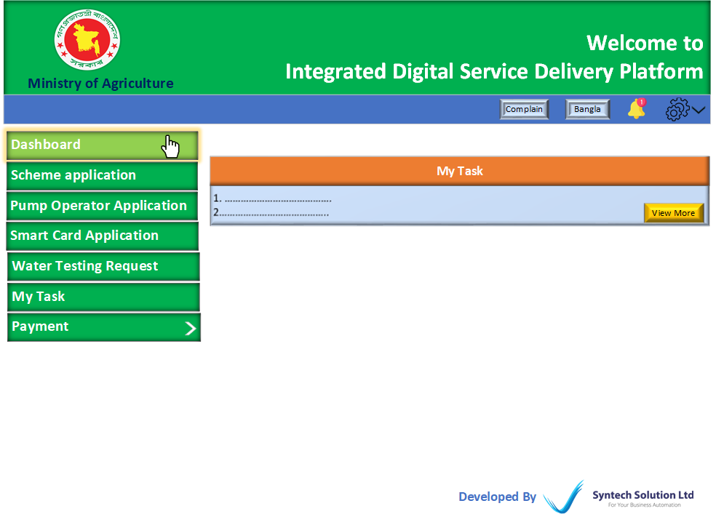

## **Scheme Application (Feature)**

* This is a scheme application option for farmers.
* System will automatically remind for payment with submission.
* Without payment, the application will Not be submitted and the form will be saved as draft.
* The same address should be place with checkbox as (Same as applicant address).
* Integrated with SMS Gateway, Payment gateway,

|  |  |  |  |  |  |  |  |  |  |  |  |  |  |  |  |  |  |  |  |  |  |  |  |  |  |  |  |  |  |  |  |  |  |  |  |  |  |  |  |  |  |  |  |  |  |  |  |  |  |  |  |  |  |  |  |  |  |  |  |  |  |  |  |  |  |  |  |  |  |  |  |  |  |  |  |  |  |  |  |  |  |  |  |  |  |  |  |  |  |  |  |  |  |  |  |  |  |  |  |  |  |  |  |  |  |  |  |  |  |  |  |  |  |  |  |  |  |  |  |  |  |  |  |  |  |  |  |  |  |  |  |  |  |  |  |  |  |  |  |  |  |  |  |  |  |  |  |  |  |  |  |  |  |
| --- | --- | --- | --- | --- | --- | --- | --- | --- | --- | --- | --- | --- | --- | --- | --- | --- | --- | --- | --- | --- | --- | --- | --- | --- | --- | --- | --- | --- | --- | --- | --- | --- | --- | --- | --- | --- | --- | --- | --- | --- | --- | --- | --- | --- | --- | --- | --- | --- | --- | --- | --- | --- | --- | --- | --- | --- | --- | --- | --- | --- | --- | --- | --- | --- | --- | --- | --- | --- | --- | --- | --- | --- | --- | --- | --- | --- | --- | --- | --- | --- | --- | --- | --- | --- | --- | --- | --- | --- | --- | --- | --- | --- | --- | --- | --- | --- | --- | --- | --- | --- | --- | --- | --- | --- | --- | --- | --- | --- | --- | --- | --- | --- | --- | --- | --- | --- | --- | --- | --- | --- | --- | --- | --- | --- | --- | --- | --- | --- | --- | --- | --- | --- | --- | --- | --- | --- | --- | --- | --- | --- | --- | --- | --- | --- | --- | --- | --- | --- | --- | --- | --- | --- | --- |
| Apply for a Scheme (Button)   |  |  |  |  | | --- | --- | --- | --- | | Field Name | Data Type | Data Length | Mandatory (Yes/No) | | Select Organization | N/A | N/A | Yes | | Scheme Type | N/A | N/A | Yes | | Applicant’s Name  (Applicant Details) | Varchar | N/A | Yes | | Father’s Name  (Applicant Details) | Varchar | N/A | Yes | | Mother’s Name  (Applicant Details) | Varchar | N/A | Yes | | NID | Int | N/A | Yes | | District  (Applicant Details) | N/A | N/A | Yes | | Upazila  (Applicant Details) | N/A | N/A | Yes | | Union  (Applicant Details) | N/A | N/A | Yes | | Village  (Applicant Details) | Varchar | N/A | Yes | | Mobile No  (Applicant Details) | Int | N/A | Yes | | Applicant’s Name  (Scheme Manager Details) | Varchar | N/A | Yes | | Father’s Name  (Applicant Details) | Varchar | N/A | Yes | | Mother’s Name  (Applicant Details) | Varchar | N/A | Yes | | NID | Int | N/A | Yes | | District  (Scheme Manager Details) | N/A | N/A | Yes | | Upazila  (Scheme Manager Details) | N/A | N/A | Yes | | Union  (Scheme Manager Details) | N/A | N/A | Yes | | Village  (Scheme Manager Details) | Varchar | N/A | Yes | | Mobile No  (Scheme Manager Details) | Int | N/A | Yes | | Division  (Proposed Pump Address) | N/A | N/A | Yes | | District  (Proposed Pump Address) | N/A | N/A | Yes | | Upazila  (Proposed Pump Address) | N/A | N/A | Yes | | Union  (Proposed Pump Address) | N/A | N/A | Yes | | Mauza(Proposed Pump Address) | Varchar | N/A | Yes | | J/L No  (Proposed Pump Address) | Varchar | N/A | Yes | | Plot No  (Proposed Pump Address) | Varchar | N/A | Yes | | General Minutes  (Attachment) | N/A | N/A | Yes | | List of scheme lands  (Attachment) | N/A | N/A | No | | Scheme Map  (Attachment) | N/A | N/A | No | | Affidavit | N/A | N/A | Yes |   Submit   |  |  |  |  |  |  |  |  |  |  |  |  |  |  |  |  |  |  |  |  |  |  |  |  |  | | --- | --- | --- | --- | --- | --- | --- | --- | --- | --- | --- | --- | --- | --- | --- | --- | --- | --- | --- | --- | --- | --- | --- | --- | --- | | (Table Format)   |  |  |  |  |  |  |  |  |  |  |  |  | | --- | --- | --- | --- | --- | --- | --- | --- | --- | --- | --- | --- | | **SL No** | **Application Id** | **Applicant Name** | **Address** | **Scheme Manager Name** | **Scheme Type** | **Proposed Pump Address** | **Attachment** | **Payment Status** | **Application Status** | **Notes** | **Action** | |  |  |  |  |  |  |  | Link | Not Paid,  Form fee Paid,  Participation Fee paid | Pending,  Processing,  Approved,  Licensed,  Installed, Resink |  | View (Button)  Edit (Button), Apply Resinik (Button) | |  * Farmer can view application status by several steps. * Edit & cancel button will Not work after complete submission with payment. * Using of “Apply Resink” Button, the application will be in edit mode, user can resubmit application for existing pump. * Form fee will not applicable for resink. Farmer only pay participation fee. |

## **Pump Operator Application (Feature)**

* Here farmer can apply to be a pump operator for multiple time.
* Integrated with NID/Porichoy.

|  |  |  |  |  |  |  |  |  |  |  |  |  |  |  |  |  |  |  |  |  |  |  |  |  |  |  |  |  |  |  |  |  |  |  |  |  |  |  |  |  |  |  |  |  |  |  |  |  |  |  |  |  |  |  |  |  |  |  |  |  |  |  |  |  |  |  |  |  |  |  |  |  |  |  |  |  |  |  |  |  |  |  |  |  |  |  |  |  |  |  |  |  |  |  |  |
| --- | --- | --- | --- | --- | --- | --- | --- | --- | --- | --- | --- | --- | --- | --- | --- | --- | --- | --- | --- | --- | --- | --- | --- | --- | --- | --- | --- | --- | --- | --- | --- | --- | --- | --- | --- | --- | --- | --- | --- | --- | --- | --- | --- | --- | --- | --- | --- | --- | --- | --- | --- | --- | --- | --- | --- | --- | --- | --- | --- | --- | --- | --- | --- | --- | --- | --- | --- | --- | --- | --- | --- | --- | --- | --- | --- | --- | --- | --- | --- | --- | --- | --- | --- | --- | --- | --- | --- | --- | --- | --- | --- | --- | --- | --- | --- |
| Pump Operator Application (Button)   |  |  |  |  | | --- | --- | --- | --- | | Field Name | Data Type | Data Length | Mandatory (Yes/No) | | Select Organization | N/A | N/A | Yes | | Pump Id | Varchar | N/A | No | | Applicant’s Name | Varchar | N/A | Yes | | Father’s Name | Varchar | N/A | Yes | | Mother’s Name | Varchar | N/A | Yes | | NID No | Int | N/A | Yes | | Mobile Number | int | N/A | Yes | | Division  (Address) | N/A | N/A | Yes | | District  (Address) | N/A | N/A | Yes | | Upazila  (Address) | N/A | N/A | Yes | | Union  (Address) | N/A | N/A | Yes | | Village  (Address) | N/A | N/A | Yes | | Date of Birth | Date | N/A | Yes | | Educational Qualification (Last) | Varchar | N/A | No | | Document Name  (Attachment) | Varchar | N/A | No | | Upload  (Attachment) | N/A | N/A | No | | Add More  (Attachment) | N/A | N/A | No |   Submit   |  |  |  |  |  |  |  |  |  |  |  |  |  |  |  |  |  |  |  |  |  |  |  | | --- | --- | --- | --- | --- | --- | --- | --- | --- | --- | --- | --- | --- | --- | --- | --- | --- | --- | --- | --- | --- | --- | --- | | (Table Format)   |  |  |  |  |  |  |  |  |  |  |  | | --- | --- | --- | --- | --- | --- | --- | --- | --- | --- | --- | | **SL No** | **Application Id** | **Applicant Name** | **Address** | **Pump Location** | **Attachment** | **Application Status** | **Application Type** | **Notes** | **Payment Status** | **Action** | |  |  |  |  |  | Link | Processing,  Approved,  Rejected,  Active | New/ Renew |  | Not Paid, paid | View (Button)  Renew (Button) |  * Applicant can view status. | |

## **Smart Card Application (Feature)**

* Here farmers can apply for smart cards.
* Integrated with NID/Porichoy.

|  |  |  |  |  |  |  |  |  |  |  |  |  |  |  |  |  |  |  |  |  |  |  |  |  |  |  |  |  |  |  |  |  |  |  |  |  |  |  |  |  |  |  |  |  |  |  |  |  |  |  |  |  |  |  |  |  |  |  |  |  |  |  |  |  |  |  |  |  |  |  |  |  |  |  |  |  |  |  |  |  |  |  |  |  |  |  |  |  |  |  |  |  |  |  |  |  |  |  |  |  |  |  |  |  |  |  |  |  |  |  |  |  |  |  |  |  |  |  |  |  |  |  |  |
| --- | --- | --- | --- | --- | --- | --- | --- | --- | --- | --- | --- | --- | --- | --- | --- | --- | --- | --- | --- | --- | --- | --- | --- | --- | --- | --- | --- | --- | --- | --- | --- | --- | --- | --- | --- | --- | --- | --- | --- | --- | --- | --- | --- | --- | --- | --- | --- | --- | --- | --- | --- | --- | --- | --- | --- | --- | --- | --- | --- | --- | --- | --- | --- | --- | --- | --- | --- | --- | --- | --- | --- | --- | --- | --- | --- | --- | --- | --- | --- | --- | --- | --- | --- | --- | --- | --- | --- | --- | --- | --- | --- | --- | --- | --- | --- | --- | --- | --- | --- | --- | --- | --- | --- | --- | --- | --- | --- | --- | --- | --- | --- | --- | --- | --- | --- | --- | --- | --- | --- | --- | --- | --- | --- |
| New Application (Button)   |  |  |  |  | | --- | --- | --- | --- | | Field Name | Data Type | Data Length | Mandatory (Yes/No) | | Organization | N/A | N/A | Yes | | Farmer’s Name | Varchar | N/A | Yes | | Father’s Name | Varchar | N/A | Yes | | Mother’s Name | Varchar | N/A | Yes | | Marital Status | N/A | N/A | Yes | | Husband’s/Wife’s Name | Varchar | N/A | No | | No. of Children | int | N/A | No | | NID No | Int | 50 | Yes | | Mobile No | int | N/A | Yes | | Gender | N/A | N/A | Yes | | District | N/A | N/A | Yes | | Upazila | N/A | N/A | Yes | | Union | N/A | N/A | Yes | | Village Name | Varchar | N/A | Yes | | Ward No | Varchar | N/A | No | | Date of Birth | Date | N/A | Yes | | Educational Qualification (Last) | Varchar | N/A | Yes | | Total Land (Auto)  [Quantity of Land (Sotok)] | N/A | N/A | N/A | | Owned Land  [Quantity of Land (Sotok)] | float | N/A | Yes | | Land Lease  [Quantity of Land (Sotok)] | float | N/A | Yes | | Barga Land  [Quantity of Land (Sotok)] | float | N/A | Yes | | Agriculture Related Received Training Info | Varchar | N/A | No | | Earnings Without Agriculture | float | N/A | No | | Crop Plan Details | Varchar | N/A | No |  |  |  |  |  |  |  |  |  |  |  |  |  |  |  |  |  |  |  |  |  |  |  |  | | --- | --- | --- | --- | --- | --- | --- | --- | --- | --- | --- | --- | --- | --- | --- | --- | --- | --- | --- | --- | --- | --- | --- | | Application List (Table Format)   |  |  |  |  |  |  |  |  |  |  |  | | --- | --- | --- | --- | --- | --- | --- | --- | --- | --- | --- | | **SL No** | **Application Id** | **Applicant Name** | **Address** | **Status** | **Payment Status** | **Print Card** | **Review Note** | **Reject Note** | **Apply for Renew** | **Duplicate Card Apply** | |  |  |  |  | Pending,  Processing,  Approved,  Generated,  Issued, |  | Link |  |  | Renew (Button) | Apply (Button) | | |

## **Water Testing Request (Feature)**

* Here farmers can request for water tests multiple times.
* Farmers will pay a testing fee while applying.
* Farmers will get sample numbers.

|  |  |  |  |  |  |  |  |  |  |  |  |  |  |  |  |  |  |  |  |  |  |  |  |  |  |  |  |  |  |  |  |  |  |  |  |  |  |  |  |  |  |  |  |  |  |  |  |  |  |  |  |  |  |  |  |  |  |  |  |  |  |  |  |  |  |
| --- | --- | --- | --- | --- | --- | --- | --- | --- | --- | --- | --- | --- | --- | --- | --- | --- | --- | --- | --- | --- | --- | --- | --- | --- | --- | --- | --- | --- | --- | --- | --- | --- | --- | --- | --- | --- | --- | --- | --- | --- | --- | --- | --- | --- | --- | --- | --- | --- | --- | --- | --- | --- | --- | --- | --- | --- | --- | --- | --- | --- | --- | --- | --- | --- | --- |
| Request for water testing (Button)   |  |  |  |  | | --- | --- | --- | --- | | Field Name | Data Type | Data Length | Mandatory (Yes/No) | | Select Organization | N/A | N/A | Yes | | Testing Type (Drinking Water/Irrigation Water/Industrial Water) | N/A | N/A | Yes | | Applicant’s Name | Varchar | N/A | Yes | | District  (Address) | N/A | N/A | Yes | | Upazila  (Address) | N/A | N/A | Yes | | Union  (Address) | N/A | N/A | Yes | | Village  (Address) | N/A | N/A | Yes | | From Date  (Schedule for Send Sample) | Date | N/A | Yes | | To Date  (Schedule for Send Sample) | Date | N/A | Yes | | Submit and Pay | | | |  |  |  |  |  |  |  |  |  |  |  |  |  |  |  |  |  |  |  |  |  |  | | --- | --- | --- | --- | --- | --- | --- | --- | --- | --- | --- | --- | --- | --- | --- | --- | --- | --- | --- | --- | --- | | Application List (Table Format)   |  |  |  |  |  |  |  |  |  |  | | --- | --- | --- | --- | --- | --- | --- | --- | --- | --- | | **SL No** | **Application Id** | **Applicant Name** | **Authority Name** | **Testing Type** | **Address** | **Payment Status** | **Sample Number** | **Status** | **View Report** | |  |  |  |  |  |  | Paid, Not Paid |  | Pending/  Processing/  Sample Collected/  Reported | View (Button) |  * Here farmers will view status and reports. | |

## **My Task (Feature)**

* This feature is only for selected pump operator.
* The task will appear here from the “Task management system” admin panel.
* Operator will report for individual task.

|  |  |  |  |  |  |  |  |  |  |  |  |  |  |  |  |  |  |  |  |  |  |  |  |  |  |  |  |  |  |  |  |  |  |  |  |  |  |  |  |  |  |
| --- | --- | --- | --- | --- | --- | --- | --- | --- | --- | --- | --- | --- | --- | --- | --- | --- | --- | --- | --- | --- | --- | --- | --- | --- | --- | --- | --- | --- | --- | --- | --- | --- | --- | --- | --- | --- | --- | --- | --- | --- | --- |
| |  |  |  |  |  |  |  |  |  |  |  |  |  |  |  |  |  |  |  |  |  | | --- | --- | --- | --- | --- | --- | --- | --- | --- | --- | --- | --- | --- | --- | --- | --- | --- | --- | --- | --- | --- | | Task List (Table Format)   |  |  |  |  |  |  |  |  |  |  | | --- | --- | --- | --- | --- | --- | --- | --- | --- | --- | | SL No | Task Id | Task Name | Schedule | Attachment | Task Note | Review Note | Status  (Pending, Complete, Verified) | Task Calendar Date | Action | |  |  |  |  | Link |  | (From Task Tracker) |  | (From Task Report button) | Task Report  (Button) | |   Task Report (Button)   |  |  |  |  | | --- | --- | --- | --- | | Field Name | Data Type | Data Length | Mandatory (Yes/No) | | Task Completion  (Complete, Partial) | N/A | N/A | Yes | | Attachment | N/A | N/A | No | | Note | Varchar | N/A | Yes | | Task Date | Date | N/A | Yes | |

## **Payment (Feature)**

* Here Service receiver can pay category wise payment
* Integrated with Payment Gateway, SMS Gateway.

|  |  |  |  |  |  |  |  |  |  |  |  |  |  |  |  |  |  |  |  |  |  |  |  |  |  |  |  |  |  |  |  |  |  |  |  |  |  |  |  |  |  |  |  |  |  |  |  |  |
| --- | --- | --- | --- | --- | --- | --- | --- | --- | --- | --- | --- | --- | --- | --- | --- | --- | --- | --- | --- | --- | --- | --- | --- | --- | --- | --- | --- | --- | --- | --- | --- | --- | --- | --- | --- | --- | --- | --- | --- | --- | --- | --- | --- | --- | --- | --- | --- | --- |
| |  |  |  |  | | --- | --- | --- | --- | | Scheme Payment | | | | | Field Name | Data Type | Data Length | Mandatory (Yes/No) | | Scheme Payment  (Scheme Form Fee/ Participation Fee) | Varchar | N/A | Yes |  |  |  |  |  | | --- | --- | --- | --- | | Card Payment | | | | | Field Name | Data Type | Data Length | Mandatory (Yes/No) | | Card Payment  (Card Application Fee/Renew Fee) | Varchar | N/A | Yes |  |  |  |  |  | | --- | --- | --- | --- | | Pump Operator Fee | | | | | Field Name | Data Type | Data Length | Mandatory (Yes/No) | | Pump Operator Fee  (Security Payment/Renew Fee) | Varchar | N/A | Yes |  |  |  |  |  | | --- | --- | --- | --- | | Water Testing Fee | | | | | Field Name | Data Type | Data Length | Mandatory (Yes/No) | | Water Testing Fee  (Irrigation Water Testing Fee/Drinking Water Testing Fee) | Varchar | N/A | Yes | |

## **Complain**

* Here Service receiver can complain for any reason.

|  |  |  |  |  |  |  |  |  |  |  |  |  |  |  |  |  |  |  |  |  |  |  |  |  |  |  |  |  |  |  |  |  |  |  |  |  |  |  |  |  |  |  |  |  |  |  |  |  |  |  |  |  |  |  |  |  |  |  |  |  |
| --- | --- | --- | --- | --- | --- | --- | --- | --- | --- | --- | --- | --- | --- | --- | --- | --- | --- | --- | --- | --- | --- | --- | --- | --- | --- | --- | --- | --- | --- | --- | --- | --- | --- | --- | --- | --- | --- | --- | --- | --- | --- | --- | --- | --- | --- | --- | --- | --- | --- | --- | --- | --- | --- | --- | --- | --- | --- | --- | --- | --- |
| |  |  |  |  | | --- | --- | --- | --- | | New Complain (Button) | | | | | Field Name | Data Type | Data Length | Mandatory (Yes/No) | | Organization | N/A | N/A | Yes | | Division | N/A | N/A | Yes | | District | N/A | N/A | Yes | | Upazila | N/A | N/A | Yes | | Union | N/A | N/A | Yes | | Subject | Varchar | 256 | Yes | | Details (Text Editor) | Varchar | 256 | Yes | | Upload (Attachment) | N/A | N/A | No |   Submit  Complain List (Table Format)   |  |  |  |  |  |  |  |  |  |  | | --- | --- | --- | --- | --- | --- | --- | --- | --- | --- | | SL No | Organization | Complain Id | District | Subject | Date | Details | Attachment | Status | Note | |  |  |  |  |  |  | View  (Button) |  | Pending /Closed/ Sent for action/ Complete/  Reviewed | (Notes from action) | |

## **Rating & Feedback**

* Here Service receivers can complain for any reason.

|  |  |  |  |  |  |  |  |  |  |  |  |  |  |  |  |  |  |  |  |  |  |  |  |  |  |  |  |  |  |  |
| --- | --- | --- | --- | --- | --- | --- | --- | --- | --- | --- | --- | --- | --- | --- | --- | --- | --- | --- | --- | --- | --- | --- | --- | --- | --- | --- | --- | --- | --- | --- |
| |  |  |  |  | | --- | --- | --- | --- | | Rating & Feedback (Button) | | | | | Field Name | Data Type | Data Length | Mandatory (Yes/No) | | Organization | N/A | N/A | Yes | | Rating  (Example:5 Star) | N/A | N/A | Yes | | Feedback | Varchar | N/A | No |   Submit  Rating & Feedback List(Table Format)   |  |  |  |  |  | | --- | --- | --- | --- | --- | | SL No | Organization | Rating | Feedback | Action | |  |  |  |  | Edit (Button)  Delete (Button) |  * Service receivers can rate and feedback for a single organization at once.   (EX: If 3 organization; user can only rate 3 time)   * Users can Delete and edit the existing rating and feedback. |